2019 Cub Scout and Family Fun
Activities put on by Capital Area Council Camping Staff

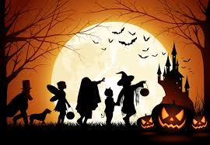
October 26th - 27th
Smilin V Scout Ranch in Liberty Hill
$20 per youth/$5 adult (children under 5 free)

Saturday the 26th
1-5pm Carnival type activities for the entire family
5-6pm Dinner provided by your family or Pack and change into your costume
6-7pm Halloween Cartoons at the pavilion by the staff while families/packs decorate their campsite.
7-8 pm Tent-Or-Treating
8-9pm More Halloween cartoons/Stargazing and not so Scary Haunted Trail Hike
10pm Lights out and time to go to sleep in your tent with your family

Sunday 27th
7-9am Breakfast with your family or Pack
9am Scouts Own Service
11am Everyone enjoys their drive home
** If your pack/ family wants to enjoy the evening fun you must bring candy for the Tent or Treat and decorate your camping area. Otherwise just come for the fun afternoon activities from 1-5pm.
** Please indicate at time of registration if you will be staying for the evening or just the afternoon. Register at http://bsacac.org/activities/for_cub_scouts. Registration for this event OPENS August 31^{st.}
Calling All BEARS: Earn your Grin and Bear It Elective Loop by hosting a fun carnival booth!!
Email teresa.northcutt@scouting.org for more info.

