Lost Pines Scout Reservation

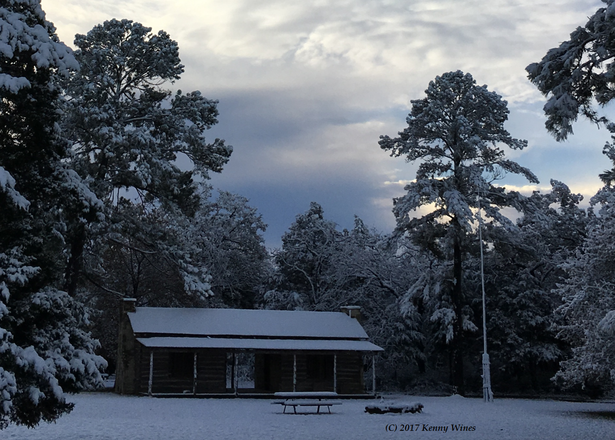
Winter Camp 2019
Leader’s Guide

Session 1: December 27‐31, 2019 – Five Days (Friday through Tuesday)

Session 2: January 2‐5, 2020 – Four Days (Thursday through Sunday)

Table of Contents

Introduction 4
Camp Telephone & Address 4
Preparing for Camp 5
Register Your Troop 5
Requesting Camperships 5
Select Merit Badges 5
Recruit Adults 5
Collect Current Medical 5
Dietary Needs 5
Electronic Devices & Internet 5
Provisional Scouts 6
Out-of-Council Units 6
Changes to Your Reservation 6
Refund Policy 6
Arriving at Camp 7
Unit Check-In 7
Medical Recheck: 7
Vehicles 7
Sharing Campsites 7
Merit Badge Class Changes 8
Flag Retreat/Dinner 8
Troop Cracker Barrel 8
During Camp (Campsite, Policies, Resources) 8
Conduct Policy 8
Uniform and Shoes 8
Camp Commissioners 8
Bathhouse Cleaning 9
Bicycles & Helmets on Camp 9
Fires & Fuels 9
Tobacco, Alcohol, Drugs, Fireworks, Firearms, Knives & More 9
Tools 9
Visitors 9
Lost and Found 9
Camp Staff Area 9
Trading Post 10
Adults During Camp Week 10
Coffee & Internet 10
Volunteer 10
Adult Training 10
Adult Leader Meeting 10
SPL Meeting 10
Health and Safety 10
Health Lodge 11
Medications 11
A Scout is Reverent! 12
Grace 12
Chapel Service 12
Schedule Overview 12
Program Areas 12
Eagle Quest 12
Evening Activities 12
Dining & Diet 12
Daily Schedule 13
Evening Schedule 13
Order of the Arrow 14
At the End of Camp 15
Merit Badge Completion Report 15
Family Night Dinner 15
Checkout Process 15
Merit Badges, Activities, Programs Schedule 16
Map to Lost Pines 18
Individual Scout Equipment 19
Troop Equipment 20
Medication Log 21
Health Screening 22
Texas Youth Camps Safety and Health Act FORM 23
Campership Assistance Form 24

Welcome to Lost Pines Scout Reservation. As an adult leader bringing your troop to Winter Camp at
Lost Pines, you will be providing your Scouts with an experience that they will remember for the rest of their lives. They will advance in Scouting along the Trail to Eagle by completing key Eagle required merit badges – many that are not oﬀered at any area Summer Camp. They’ll also be able to take a variety of elective merit badges and participate in a few special programs. Most of all, they’ll have a great time and will come home with a real feeling of accomplishment.

Adults will find Winter Camp a pleasant experience (winter at Lost Pines is usually relatively mild), and a great opportunity to take or renew adult training.

Lost Pines is routinely inspected and meets the standards established by the B.S.A. National Oﬃce for an Accredited Boy Scout Resident Camp. Lost Pines is also annually inspected by the State of Texas Department of State Health Services. All of our key staﬀ members are trained through the B.S.A. National Camp School system.

Toni Nelson Teresa Northcutt
Camp Director Council Program Director
(512) 736-2806 (512) 944-7726
txtoni13@gmail.com teresa.northcutt@scouting.org

Lost Pines Scout Reservation
785 FM 1441
Bastrop, TX 78602
512-303-0768

Important Dates
Winter Camp Fee: | Date DUE
Campsite Reservation | With Registration | $25 per Scout
Scout Deposit | By October 30 | $100 per Scout
Scout Final Payment | By November 30 | $95 per Scout
Adult Payment | By November 30 | $95 per Adult

Why are they “Lost Pines”?
The 537 acres of Lost Pines Scout Reservation are part of a 75,000 acre area of central-eastern Bastrop County which contains a substantial population of loblolly pines*. Early settlers referred this area as the “Lost Pines” because it is separated from the pine forest of East Texas by a distance of around 80 miles. These tall pines are possibly the remnant of a larger pine forest along the Colorado River, which shrank during or soon after the Pleistocene, or Ice Age, an epoch stretching from about 1.65 million to 10,000 years ago. Some ancient, possibly geological event such as a moving glacier worked to separate the Lost Pines from their East Texas cousins. In other words, these pines have been “lost” since long before Europeans came to Texas!

*Loblolly - a pine species with flaky bark, spiny-tipped cones and long needles in groups of three, are found throughout the southern United States.

Preparing for Camp
Register Your Troop
ALL Troops must submit a Winter Camp Reservation Form (https://www.bsacac.org/wp-content/uploads/2019/08/2019-Winter-Camp-Reservation-form.docx) or contact Keri Smeaton at the Council office at 512-617-8610 or keri.smeaton@scouting.org to reserve your week and pay your deposit. The deposit is $25 per Scout estimated in attendance and is non-refundable. Please make sure you are not overestimating the number of Scouts attending.

Even if your Troop has an active on-line account, you will not be allowed to register further until you have made your deposit through the Council office. Once your Troop has been registered, your Troop designee will be given the necessary access and instructions to enter the names of those Scouts and adults attending camp.

Submit First Payment ($100 per scout) by October 30

Request Campership Grants by October 15
A limited number of camperships are available each year for Scouts that have severe financial hardships. Troops should encourage Scouts to earn their own way through unit fundraisers. Camperships cover up to 50% of the camp fee. Please use the campership application (https://www.bsacac.org/wp-content/uploads/2019/05/camperhsip_assistance_form.pdf) to apply. This application must be submitted to the Council by October 15.

Select Merit Badges for Your Scouts before November 30
Use the Program Guide section of this book to help determine course schedules for each of your Scouts. Please pay special attention to age requirements, prerequisites and requirements that will not be completed at camp. Be sure to register for merit badges early as some classes fill up quickly! You can select courses in DoubleKnot until November 30. After that, all requests must be emailed to the Registrar.

Recruit Adult Leadership and Submit Forms by November 30
Important BSA policy Changes: Effective 05/2018 ALL adults attending camp must be registered members of BSA. Two registered adult leaders over 21 years of age are required for all Scouting activities. ALL adults attending camp and staying overnight with a troop must comply with the following:
- Complete the new on-line Youth Protection Training (dated after March 13, 2018);
- Complete the Texas Youth Camps Health and Safety Act Form (http://www.bsacac.org/formssummercamp.php); and
To make your check-in process as quick as possible at camp, submit the necessary adult forms to Council at 564roster@scouting.org no later than November 30.

Submit Final Payment ($95 per Scout and $95 per adult) by November 30

Collect Current Medical Forms Early & Prepare Binder for Check-In
Every Scout and Adult attending camp will need a completed BSA Medical Form parts A, B and C with a physician signature dated within the last 12 months. Note that Part C requires a Tetanus booster within the last 10 years. You will need to turn these in to the Camp Health Officer at check-in. Make a copy of all forms, leave the original at home and bring all forms in a binder alphabetized with Scouts in front and adults in back.

Plan for and Communicate Dietary Needs
Lost Pines strives to provide options to fit a number of dietary needs with every meal. Upon request, we can provide gluten free and vegetarian options for those with dietary restrictions. When registering, please be sure to indicate if members of your Troop will require gluten free or vegetarian meals. We do acknowledge that we cannot accommodate some dietary needs. For those instances, microwaves and refrigerators/ freezers are available in the back of the Dining Hall for camper and leader use.

Electronic Devices and Internet Access
Lost Pines offers wireless internet access to camp attendees at many common-areas across camp. Access is intended as a privilege to be used in accordance with Scouting’s values for the purpose of furthering Scouting experiences while at camp. It is the responsibility of unit leaders to decide if their Scouts are allowed to bring mobile electronic devices including but not limited to cell phones, tablets, and laptops and to establish standards for the usage of these devices within their unit. If units elect to allow mobile electronic devices, it is up to the unit leaders to be sure their Scouts have completed the necessary Cyber Chip requirements.

While this system features similar categorical firewall content restrictions, site blocking, and protection that you would expect with most elementary schools, by accessing the Lost Pines Network, individual users agree that The Boy Scouts of America, including the Capitol Area Council and Lost Pines Camp Staff assumes zero liability or risk for data transmitted through the Lost Pines Network by personal devices while connected to the network. Users are solely responsible and legally liable for any/all data accessed/transmitted through their device while connected to the Lost Pines network. The Capitol Area Council and camp staff reserves the right to revoke or limit network access to any user or device at any time without notice.

Please note that some merit badges require the use of internet in order to complete the requirements.

Provisional Scouts

While it is preferred that Scouts attend camp with their Troop, we recognize that there are Scouts who would like to come to Lost Pines when their Troop doesn’t attend. We will accommodate these Scouts as Provisional Scouts by placing them in their own Troop or with another Troop registered for the week requested. They will follow the guidance of that Troop’s adult leaders while at camp.

Provisional Scouts must register through Keri Smeaton, keri.smeaton@scouting.org. A $100 non-refundable deposit is required at the time of registration. The fee for individual (provisional) Scouts will be $230. If a parent is attending camp with a provisional Scout, the $95 leader fee will apply.

Troops who cannot meet the two-adult minimum requirement are encouraged to partner with another troop in advance to meet this requirement. Notify the Council when registering for camp so that we can insure both Troops are placed in the same campsite. When 4 or more Scouts from the same unit are wanting to camp as a Provisional Troop, adult leadership is expected and registration may be denied if leadership is not provided.

Special Note for Out-of-Council Units
All registered members (youth and adult) of the Capitol Area Council are covered by the Council accident and sickness insurance policy. Out-of-Council units must provide proof of insurance at check-in. Your home Council should be able to provide guidance on obtaining this information.

Changes to Your Reservation
Please contact the Council office for availability should your attendance numbers change from your initial reservation estimate. NEW SCOUTS who join your troop after the November 30 reservation deadline must pay as soon as possible. Balances are still due by the final fee payment date. Should your Troop have a decrease in the number of Scouts who will be attending camp between September 1 and your final payment date, December 1, please notify the Council office.

Refund Policy
For the Council’s full Refund Policy please go to http://www.bsacac.org/about/refund_policy.

The Campsite Reservation fee of $25 per Scout is not refundable if the Troop does not come to camp.

Any other Refund Requests must be submitted within ten (10) days following the end of the applicable activity and may be subject to a twenty-five percent (25%) program recovery fee according to the policies.
Arriving at Camp
Camp check-in begins at 1pm on Day 1 of camp and Troops are asked to arrive before 3:30pm. We ask that you view our check-in video at https://youtu.be/5iAgi63mwZ8 for an overview of the check-in process and how to make it faster and easier for your unit.

Upon arrival at camp, please park all vehicles in the designated lot. Staff will be available to escort your Troop’s trailer to your campsite or assist in transporting gear for Troop’s without a trailer.

The troop must report to Lindsay Lodge for troop check-in and medical check-in.

At Lindsay Lodge, there will be an easily identifiable camp staff member who will connect your Scouts with their Camp Troop Guide and direct the adult leaders to the appropriate location. You will have the option of (a) leaving your Scouts outside Lindsay with their Troop Guide(s) or (b) allowing the Troop Guide(s) to take them on a camp tour while you complete the check-in process.

If you have two adult leaders, you can speed up the process by having one handle the unit check-in and one do the medical recheck.
- Unit Check-In: Conducted in Lindsay Lodge, this is a multi-step process where you will do the following:
  - Verify all adult leader forms (TX Youth Camps form and YPT cards)
  - Verify camp attendance versus registered and dietary restrictions (gluten free and vegetarian only)
  - Provide proof of BSA registration for all adults at camp (copy of BSA Membership Card or current unit roster printed from my.scouting.org)
  - Pick up your check-in packet which contains wristbands to be worn at all times and other valuable camp information
  - Provide on-site adult leader contact information
  - Sign-up for flag ceremonies, grace before meals and Scout’s Own worship service
- Medical Recheck: Conducted in the Health Lodge adjacent to Lindsay Lodge, you will need to provide the following:
  - Medical Forms: Anyone staying on camp must have the BSA Medical Form parts A, B and C with a physician signature within the last 12 months (please note that school physical forms do not meet the BSA requirement and cannot be accepted). The troop is encouraged to bring medical forms in a three-ring binder with two sections. Scouts’ forms should be in alphabetical order in the first section and adult leaders’ forms in alphabetical order in the second section.
  - Health Screening Form completed prior to camp
  - Medication Log for your Troop. All medications must be managed by an adult leader. You will also be asked to verify the medications will be stores behind two locks, as per BSA requirements.
  - Any Scouts/adults with Epi-Pens or inhalers will need to see the medic at this time

Following check-in, if not already done, a staff Troop Guide will take your Troop on a camp tour of the main camp area. The tour will include the Dining Hall where the Scouts will learn of their assigned table they will be responsible for during the week and how to enter for meals as well as pick up mugs to be used throughout camp.

Vehicles
NO vehicles will be allowed in the campsites. You may park one trailer with attached vehicle outside your campsite as identified by the camp. If you require assistance in transporting gear into your campsite, please make a request during check-in.

Sharing Campsites
All Troops should expect to share their campsite with another Troop. Please be courteous and do not take over the entire campsite including fire rings, picnic tables, pavilions and tents.

Merit Badge Class Changes
There is an opportunity after check in on Day 1 to make changes in your Scouts’ schedules. Remember, some merit badges may no longer be available.

Flag Retreat/Dinner
All troops should report to the parade ground flagpole by 5:40 pm in Class-A uniform for the formal flag retreat and any announcements. Troops are released from the flag assembly one at a time to go to the dining hall for dinner. Please make sure your Scouts walk from the flag assembly to the dining hall!

Troop Cracker Barrel
At 8pm on Day 1 your Troop Guide will bring snacks to your campsite to participate in cracker barrel with your unit. They will have information to share regarding breakfast and other events taking place during the week.

During Camp Week – Campsite, Policies and Resources

Conduct Policy
The conduct and discipline of the Scouts in your troop is YOUR responsibility. This is a camp policy that we have found to be of mutual benefit. The camp staff will not discipline your Scouts unless it is a case of imminent bodily injury or property damage. Your campsite is your home. Entering or loitering around another campsite without that troop's permission invites problems. Taps is at 10:30 pm. All campers are expected to be in their own campsite by that time. Troop activities such as night hikes, astronomy, etc., are encouraged and would constitute an exception with appropriate adult supervision. Youth campers found outside their own areas after 10:30 pm will be escorted back to the campsite by a staff member. We appreciate your cooperation.

Please abide by the Outdoor Code while at camp. Do not cut or mar trees. Help your Scouts know the importance of caring for trees and all property. Capitol Area Council prohibits the use of hammocks on all of our properties. Hammocks will not be allowed at Lost Pines Scout Reservation.

Uniforms and Shoes
The complete, official Scout field uniform is to be worn properly by Scouts and adult leaders at flag retreat and dinner. NOT PERMITTED are caps and T-shirts, etc., with words or pictures not representing the best spirit of the Scout Oath and Law. For safety reasons, completely closed shoes (sneakers or boots) are to be worn at all times. Shoes with open sides and backs (i.e. Crocs and hiking sandals) are not allowed (except in your tent, or in the shower). A Scout with a cut foot is an unhappy camper! Also, a shirt with sleeves must be worn at all times.

Camp Commissioners
One of the most important resources at camp is the Camp Commissioner staff. They are experienced Scouters who have volunteered their time to assist your Troop during your camp adventure. They will be available to answer questions and to help coordinate the various activities during the week. Camp Commissioners are a tremendous resource – if you need help with anything, please don’t hesitate to ask them!

Bathhouse Cleaning
Bathhouses are associated with campsites. The campsite your Troop is in determines which bathhouse it will use and is responsible for keeping clean. Bathhouse assignments and cleaning schedule will be provided at check-in.

Troops are responsible for cleaning their bathhouse in the afternoons and evenings. When it is your Troop’s turn, be certain that all trash and paper is picked up and disposed of, floors are swept and mopped, and toilets and sinks are unplugged and clean. Your Troop is responsible for cleaning both the youth and adult sides of the assigned bathhouse.

If repairs are necessary in the bathhouse, please inform the Camp Commissioners. If damage from vandalism occurs, your Troop is financially responsible for the cost of repairs. This cost will be allocated between the Troops assigned to the bathhouse.

Bicycles and Helmets on Camp
Bicycles with helmets are permitted on camp roads only. Rider must wear a helmet and proper clothing at all times and yield the right of way to individuals who are walking. If a bike is ridden after dar, it must be equipped with a white front light and red back light. Individuals with bicycles are responsible for following Bicycle Safety as outlined in Guide to Safe Scouting

Fires & Fuels
Ground fires are permitted during Winter Camp in a fire ring IF a burn ban is not in place. If your unit wishes to have a fire, the Troop Leaders must complete the Ten Steps to a Safe Fire form (found in your check-in packet) and have it and your Unit Fireguard form posted in the campsite

Liquid or propane fuels are to be used only under adult supervision and must be stored under lock and key. Liquid fuels cannot be used on open fires or to start a fire. National policy prohibits the use of open flames in tents. This includes mosquito coils, catalytic heaters, gas lanterns, stoves, candles, and smoking materials.

Tobacco, Alcohol, Illegal Drugs, Fireworks, Firearms, Knives and More
Adult leaders should not allow the use of tobacco products (this includes vapes) at any BSA activity involving youth participants. In addition, tobacco use in the presence of Scouts is not permitted at camp. Adult Leaders wishing to use tobacco products may do so only in the Commissioners Area. The consumption, possession, or use of any alcohol, illegal drug or controlled substance is strictly forbidden on any Capitol Area Council property. We will enforce all local, state, or federal laws where violations involving the above are reported. Fireworks, pets, personal firearms and ammunition, and personal bows and arrows, of any type are not allowed at camp. In addition, camp policy prohibits the carrying of fixed-blade knives except for the purposes of OA ceremonies and Living History night. Do not take home any wild animal. Pets of any kind are not allowed on camp unless they are a service animal. Violators will be asked to leave camp.

Tools
Camp Commissioners have an assortment of tools for your use as well as a list of available service projects. Check them out when you need them and return promptly after you have finished with them so others can use them. All equipment checked out to your Troop must be returned or paid for before you leave camp.

Visitors
All visitors to camp must check in at Administration Building immediately upon their arrival at camp.

Lost and Found
Lost and found will be kept in Dining Hall and A Building. On Day 3 morning all lost and found will be moved to the porch of A Building. Please take only what belongs to you from lost and found area. Unclaimed items will be kept at the Fickett Center for 30 days before being donated to a charitable organization.

Camp Staff Areas
Scouts are not allowed in the camp staff area at any time. We ask Troop leaders to help enforce this policy.
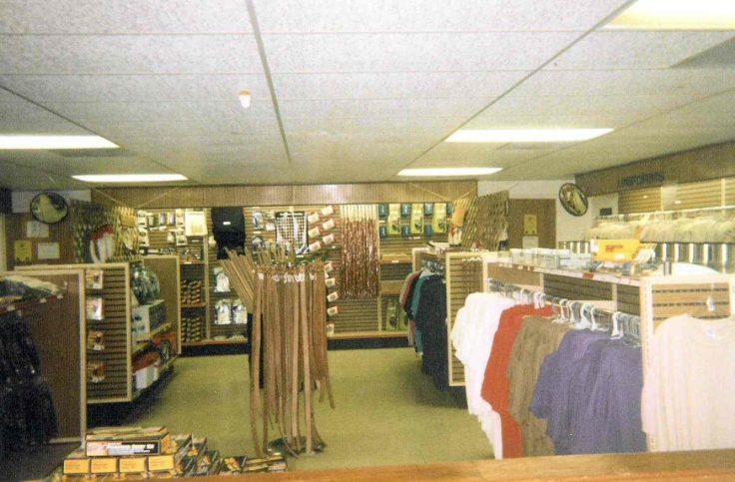
Trading Post
Ask your Scouts to use discretion when buying drinks and candy at the Trading Post. Please help us keep the drink containers, papers, and trash picked up. Various handicraft kits and supplies are offered along with T-shirts, mugs, and literature such as handbooks, and merit badge books. The Trading Post accepts major credit cards.

Adults During Camp Week
BSA policy requires two adult leaders be on camp at all times (leaders may rotate if necessary). Important BSA policy Changes: Effective 05/2018 ALL adults attending camp must be registered members of BSA. Two registered adult leaders over 21 years of age are required for all Scouting activities. Visit classes periodically to observe your Scouts. Check your mailbox in the A-Building every morning and afternoon for status updates on your scouts as well as any mail you may receive.

Even though it may be cold, watch your Scouts for dehydration. If they get headaches, homesick or aren’t hungry – make them drink water. They are very likely dehydrated. Scouts should drink at least 8oz of water per hour.
Coffee & Internet
With coffee always on and wifi readily available, adult leaders can congregate in the dining hall for refuge and a chance to catch up on some of the paper work as well as to socialize with other leaders.

Volunteer
Each adult leader who comes to camp brings special skills or teaching abilities that can benefit the camp program. If you can assist in teaching or want to instruct a merit badge, please talk with the Program Director on Day 1. Or, if you are a carpenter, electrician, plumber, or handyman, our camp can sure use your skill during the week. Bring your tools and feel as if you're still at home! Check with the Program Director or Camp Director at check-in or any time during the week.

Adult Training
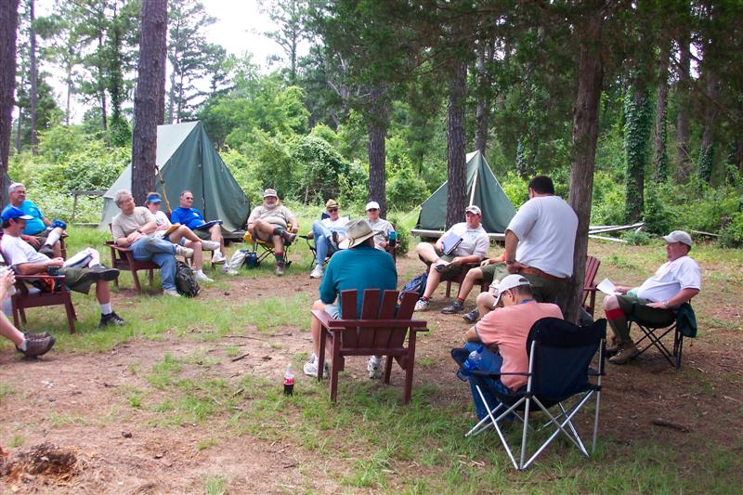
Each week, classes including Scoutmaster Position Specific, Introduction to Outdoor Leader Skills, Troop Committee Challenge and First Aid/CPR are taught to Scout leaders. The exact offerings will vary based on trainer availability. If you are interested, please consult the adult training schedule provided at check-in or ask a commissioner.

Adult Leader Meeting
Adult Leader meetings are held daily at 10am in the Dining Hall. This meeting provides the troop leadership the opportunity to discuss upcoming activities, sign up for various activities, problem solve, and learn more about camp programs and opportunities at Lost Pines. It is very important that one or more adult leaders from each troop be present at this daily meeting. If possible, all adults should attend this meeting.

SPL Meetings
Make sure your SPL (or his designee) attends the daily Senior Patrol Leaders Meetings. This meeting takes place in the Commissioner’s Area at 5:15pm. This meeting serves to provide SPL’s with the information they need regarding campsite inspection, changes to the camp program, and other information. It is mandatory that each Troop be represented at this meeting each day.

Health and Safety
The Health and Safety of the Scouts and Scouters is a primary consideration at Lost Pines. We provide a Health Lodge for minor medical care and support, to enforce the Boy Scouts of America's Health and Safety, and Youth Protection policies.

Health Lodge
One or more persons trained to handle minor accidents or illnesses staff the Health Lodge. Special arrangements for the treatment of more serious cases have been made with physicians in Bastrop. In the event such treatment is required, the camper's parents will be notified by telephone giving the nature of the emergency and their desires concerning further treatment.

It is the responsibility of the troop leadership to provide transportation for troop member(s) requiring services from a doctor or hospital. Two-deep leadership must be maintained with the injured Scout and the Troop at camp. The leader must obtain the injured Scout’s health record from the Health Lodge before going to the doctor or hospital.
Directions to doctors’ offices and hospitals are available at the Health Lodge.

Medications
Medications to be taken at camp must be controlled by the unit leader. All medications must be in the proper original containers labeled with the patient’s name, medication name and written dosage directions. Unit Leaders must have the Medication Log found in the appendix filled out and turned in at medical recheck. Adults MAY dispense medications to Scouts in the troop but must NEVER allow medication to be in the possession of a Scout. The only exceptions are epi pens and inhalers which the Scout is trained on and needs for extreme emergencies.

A Scout is Reverent
Grace
During check-in, Troops will be asked to volunteer to lead the camp in grace before meals. Troops will provide a representative to lead the camp in grace after evening flag ceremonies or in the Dining Hall line before breakfast and lunch are served. The Lost Pines Grace or the Philmont Grace is always appropriate, but other graces may be used if they are appropriate for the variety of religious beliefs that are present. If you have any questions, you may check with the Camp Chaplain, the Camp Program Director or Camp Commissioners.

Chapel Service
Please encourage Scouts to attend the Chapel Service, held Day 3 at 5:00 pm at the camp Chapel, near Fish campsite. If your Chaplain’s Aide or other Scouts wish to participate in the service, please contact the Camp Chaplain at check-in. All are welcome to attend.

Schedule Overview
Program Areas
Merit Badge and related activities at Lost Pines are designed to fit into a three-day schedule. Classes are held in three sessions in the morning with two more sessions in the afternoon Day 2 through Day 4. We recommend that Scouts obtain the merit badge pamphlets (available at the Scout Shop) prior to camp so that they can do advance study to be well prepared for camp.

MB Courses have minimum and maximum participant limits built into the event registration system. If demand is low for a particular course, it may be cancelled. Every possible effort to alert the troop contact person of changes will be made. Eagle required MB are the priority at this camp and will not be dropped. If the MB does not appear in Doubleknot, it is probably full. If you need that particular merit badge, email 564roster@scouting.org and if there is enough demand we can add a class. Scouts should give their unit representative their top 4-6 MB in order of preference. This will aid their representative in entering the classes for each Scout. MB selections are taken on a first come first serve basis

In many cases, the merit badges cannot be completed during camp (ex. Personal Management requires the Scout to develop and maintain a budget for three months). Scouts will receive “partial” credit for any merit badge showing the requirements they completed. Troops should plan their program to help their Scouts complete the merit badges after camp.

The ATV Safety Certificate Course is only open to Scouts 14 years of age or older and requires long pants, long sleeve shirt, and ankle high or higher boots.

For Climbing Merit Badge and for Open Tower you need to have pants with belt loops in order for the harness to fit properly.

Eagle Quest
Eagle Quest will be conducted all day over the four periods for Scouts still needing a lot of rank advancement for Scout, Tenderfoot, Second Class and First Class. This will allow them to work on First Aid & Leatherwork merit badges as well. Sign up for the patrol of your choice based on current rank, Eagle Quest First Aid and Eagle Quest Leatherwork merit badges so your Scout’s name will appear on all 3 rosters.

Evening Activities
There are a variety of evening activities. On Day 1, our staff will join you in your campsite for Cracker Barrel. Day 2 will be Living History night and Order of the Arrow social. Day 3 is movie night (required for Citizenship in the Nation). Day 4 is Family night and closing campfire on T-Bird Island.

Dining & Diet
Meals are served cafeteria style in our Dining Hall. To avoid crowding, your troop will have an assigned table(s). Menu will be posted to the winter camp page and should be reviewed for possible allergies. A refrigerator/freezer and microwave will be provided for individuals with special dietary needs. Food should be in Ziploc-style bags labeled with individual’s name and Troop number. All Scouts must be accompanied by an adult when getting food in the kitchen area.

SAMPLE Daily Schedule – TIMES SUBJECT TO CHANGE – Check in @ 1 PM on DAY 1.

Daily Schedule
Time |  | Activity
7:00 am |  | Breakfast
8:00 am |  | FLAG CEREMONY – all troops
8:30 - 9:30 am | 1st class period
9:40 - 10:40 am | 2nd class period
10:00 – 10:45 am | Leader Meeting
10:50 - 11:50 am | 3rd class period
12:00 pm | Lunch
2:00 - 3:00 pm | 4th class period
3:10 - 4:10 pm | 5th class period
4:10 - 5:20 pm | Open time
5:15 pm |  | SPL Meeting – Dining Hall
5:45 pm |  | FLAG CEREMONY – all troops
6:00 pm |  | Dinner
7:00 pm+ |  | Evening Programs
10:30 pm |  | Taps
11:00 pm |  | LIGHTS OUT

Evening Schedule – Session 1
Day | Time | Activity
DAY 1 | 1:00 pm  8:00 pm | Merit Badge Course Changes (only Scouts who need changes made in their schedules & their leaders)  Troop Guide provided Cracker Barrel & Campfire
DAY 2 | 12:30 pm  7:00 pm  7:00 pm  7:00 - 8:30 pm  8:30 pm | Brotherhood Candidate Meeting – A Building Porch  All Cooking MB classes meet outside of Log Cabin  Astronomy MB (Lindsay Lodge)  Living History Program – Dining Hall  Brotherhood Ceremony – Log Cabin  OA Social – Lindsay Lodge
DAY 3 | 5:00 - 5:30 pm  7:00 - 9:30 pm  7:30 - 9:30 pm | Chapel “Scouts Own” Service at Chapel  Open Tower Night  Movie Night – Dining Hall
DAY 4 | 6:00 pm  7:30 pm | Family Dinner  CLOSING CAMPFIRE

Evening Schedule – Session 2
Day | Time | Activity
DAY 1  (Thursday) | 10:00 am  5:00 pm  5:15 pm  6:30 pm  7:00 – 8:30 pm  7:00 pm  8:40 pm | Check-In  Brotherhood Candidate Meeting – A Building Porch  Leader Meeting (Dining Hall)  All Cooking MB classes meet behind Dining Hall  Living History Night (Dining Hall)  Astronomy MB (Lindsay Lodge)  OA Social (Log Cabin)
DAY 2  (Friday) | 5:00 - 5:30 pm  7:00 pm  7:00 – 9:30 pm  7:30 – 9:30 pm  7:30 pm  9:00 pm | Scouts’ Own Service (Chapel)  Astronomy MB (Lindsay Lodge)  Open Tower Night  Movie Night (Dining Hall)  OA Brotherhood Ceremony (Log Cabin)  Wilderness Survival Night (A-building porch)
DAY 3  (Saturday) | 6:00 pm  7:30 pm | Family Dinner  CLOSING CAMPFIRE
DAY 4  (Sunday) | 7:00 am  7:50 – 8:50 am  9:00 – 10:00 am  10:15 – 11:15 am  12:00 pm | Breakfast in Dining Hall  Day One 1st Period Make-up (as needed)  Day One 2nd Period Make-up (as needed)  Day One 3r^{d} Period Make-up (as needed)  Checkout

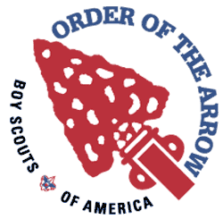
Order of the Arrow Tonkawa Lodge No. 99

Arrowmen in Camp
All Arrowmen are encouraged to pack their OA sash right next to their Scout spirit of cheerfulness and service and bring it all to camp! During Winter Camp at Lost Pines Scout Reservation, the Order of the Arrow has several duties and activities. Primarily, they run and facilitate inductions and act as an information link into Tonkawa Lodge for visiting units. They also provide units with the knowledge they need to help their OA members grow into quality youth leaders through the Order.

Ice Cream Social
Day 2 is the Order of the Arrow ice cream social. During this time the OA members on staff will give a quick synopsis of the OA’s programs and exciting upcoming events. They will inform members of how to get more involved and how the OA fits into Boy Scouting in general. OA members from any lodge are welcome to join us for the social!

Brotherhood
Also on Day 2, Ordeal members are inducted into Brotherhood membership. An Arrowman is eligible to go through the Brotherhood Ceremony if it has been more than 10 months since his Ordeal Weekend AND he is a paid member of Tonkawa Lodge. The cost will be $16, which includes a sash. National policy restricts Brotherhood candidates at winter camp to only those Ordeal members that are registered in units in the Capitol Area Council.

Call-Out
Day 4 is the most exciting day at camp for Arrowmen. This is the day of the weekly call-out, held during the closing Campfire Ceremony. Units who had new member elections during the previous year submit the names of those elected who have not been recognized or inducted yet. This is done in front of the entire camp and serves as a glimpse into our order for non-members and as an impressive way to recognize the Scouts and Scouters who have exemplified the Scout Law and Scout Oath in their everyday lives.

Those elected to be eligible to become members, called “Candidates,” have a period of one year from the date of their elections (not from the date of their call out) to complete the Ordeal weekend. If a candidate does not complete their Ordeal weekend within one year from the date of election, they must be reelected to become a candidate again. All units are requested to bring a copy of their completed unit election form to summer camp to ensure that all candidates receive proper public recognition.

Camp Promotions
OA Chapter representatives are available as a resource that can be called upon by each troop for summer camp promotions at any time during the year. This is an ideal program for a Parent's Night or Court of Honor. Please contact your Chapter Chief for details – contact information is available at http://www.tonkawa99.org.

For more information, check in A Building for the name of the Camp Chief and set up a time to meet.
At the End of Camp
Merit Badge Completion Reports
Day 4 evening, adult leaders should pick up the merit badge results and other completion materials at the A-Building. Leaders are responsible for checking their materials and making certain that they have completion information for each Scout for each course they were enrolled in. This information will show the requirements that the Scout completed during the week. Courses will be shown “COMPLETE” if the Scout completed all merit badge requirements or “PARTIAL” if there are requirements that were not completed. For partials, the requirements listed are what was completed at camp. This is your only chance to resolve issues in person with the MB instruction staff.

Any requirements not completed at camp become the responsibility of the Troop and its leaders and merit badge counselors to verify. An example of this would be the requirement for the Camping merit badge that the Scout show experience by completing 20 days and nights of camping. As this obviously cannot be done during the one camp week, the adult leaders are responsible for marking the completion status of the requirement from troop records in writing so it can be filed with the other records.

Family Night Dinner
Day 4 at 6:00pm, parents and family members are encouraged to take part in a Family Dinner and Campfire. Cost for the dinner will be $8 for adults and $5 for children under 11. The Scoutmaster needs to tell the Camp Commissioner staff how many will be attending the dinner by Day 2. All guests must check-in at A building upon arrival and pay for their dinner.

Checkout Process
Day 5 morning, when your troop gear has been loaded for departure from Lost Pines, leaders should send a representative to the Commissioners Area to have a Camp Commissioner inspect the bathhouse and campsite for cleanliness and, after the inspection is complete, release the troop for their trip home.

Before departure, be sure to check your mailbox one last time, and also check the lost and found to see if any of your Scouts’ belongings are there.

Settle all accounting with the Business Manager and make reservations for next year, pick up your patches for Scouts and paid adult leaders as well as any Tonkawa Challenge and Scoutmaster Award of Merit patches earned by members of your Troop.

Stop at the Health Lodge to pick up Troop medical forms before you leave the camp. Any medical forms left at camp will be shredded for privacy protection. In addition, please make sure you pick-up any medications, Epi-Pens or inhalers that were given to the camp Health Officer.

Be careful going home!

Merit Badges and Camp Programs

 | Merit Badge | Min ‐  Max | Requirements NOT completed at Camp, If none listed then this MB may be completed at camp | AGE LIMIT
 | American Cultures | 4‐16
 | American Heritage | 4‐16
 | Archery | 6‐16 | Depending on weather and skill
 | Astronomy | 6‐16 | Depending on weather allowing to observe the sky
 | Basketry | 4‐16
 | Bird Study | 4-16 | Depending on bird sightings
Eagle | Camping | 6‐16 | 8d & 9
 | Chemistry | 6‐16 | 7
Eagle | Citizenship in the Community | 6‐16 | 3, 4 & 7c
Eagle | Citizenship in the Nation | 6‐16
Eagle | Citizenship in the World | 6‐16 | 7a & b
 | Climbing | 6‐16 | Depending on weather and skill | 13 yr+
Eagle | Communications | 6‐16 | 8
Eagle | Cooking | 6‐16 | 4, 6, & 7d
Eagle | Cycling | 6‐10 | 7b, 4 (22 mile trip)
 | Digital Technology | 4-10
Eagle | Emergency Preparedness | 6‐16 | 2c
Eagle | Environmental Science | 6‐16
Eagle | First Aid | 6‐16 | 2d (if you don’t bring items for a first aid kit)
 | Forestry | 6‐16
 | Geocaching | 4-16 | 7 & 8
 | Indian Lore | 6‐16
 | Leatherwork | 6‐16
 | Metalworking Blacksmith Opt. | 4‐8
 | Metalworking Tinsmith Opt. | 4‐16
 | Orienteering | 4-16
Eagle | Personal Fitness | 6‐16 | 1b (dental exam) & 8
Eagle | Personal Management | 6‐16 | 2 & 8c & d
 | Pioneering | 6‐16
 | Rifle | 6‐14 | Depending on weather and skill | 12 yr +
 | Robotic | 4-16
 | Shotgun | 4‐8 | Depending on weather and skill | 13 yr+
 | Signs, Signals & Codes | 4-16
 | Space Exploration | 6‐16
 | Textiles | 4‐16
 | Wilderness Survival | 6‐16
 | Woodcarving (all material provided but knife) | 6‐14
 | ATV Safety Certification Course | 6 |  | 14 yr+
 | Eagle Quest | 4‐8
 | Scout |  | 6 & 7
 | Tenderfoot |  | 1a-b, 2, 6b-c, 9, 10 & 11
 | Second Class |  | 1, 2e, 3b, 5, 7, 8c-e, 10, 11 & 12
 | First Class |  | 1, 2, 6, 8, 9, 10, 11, 12 & 13
 | First Aid Merit Badge
 | Leatherwork Merit Badge

 | 1st Period | 2nd Period | 3rd Period | 4th Period | 5th Period | Open (Not Day 3)
 | 8:30-9:30a | 9:40-10:40a | 10:50-11:50a | 2:00-3:00 pm | 3:10-4:10 pm | 4:10-5:10 pm
Eagle Required
DH1 | Cit. Comm. (Partial) | Cit. Comm. (Partial) | Cit. Comm. (Partial) | Cit. Comm. (Partial) | Cit. Comm. (Partial)
DH2 | Citizenship Nation | Citizenship Nation | Citizenship Nation | Citizenship Nation | Citizenship Nation
DH3 | Citizenship World | Citizenship World | Personal Fitness (Part) | Citizenship World | Personal Fitness (Part)
DH4 | Communications (Partial) | Communications (Partial) | Communications (Partial) | Communications (Partial) | Communications (Partial)
DHc | Personal Manag (Part) | Personal Fitness (Part) | Personal Manag (Part) | Personal Manag (Part) | Personal Manag (Part)
Living History Cabin Porch | Amer.Culture/Hert (Partial) | Indian Lore | Signs, Sig &Codes | Signs, Sig &Codes | Textile
Trailer | Cycling (Partial) |  |  | Cycling (Partial)
Shelter | Basketry | Leatherwork | Woodcarving | Basketry | Woodcarving
Forge | Metalwork Blacksmith Opt. |  |  | Metalwork Tinsmith Opt.
Shooting Sports | Archery | Archery | Archery | Archery | Archery | Archery Open
 | Rifle Shooting | Rifle Shooting | Rifle Shooting | Rifle Shooting | Rifle Shooting | Rifle Open
 | Shotgun | Shotgun | Shotgun | Shotgun | Shotgun | Shotgun Open
Nat-e-Con
Lindsay Lodge | Chemistry | Space Exploration | Astronomy | Space Exploration | Chemistry
Tent1 | Envir. Science | Envir. Science | Envir. Science | Envir. Science | Envir. Science
Lindsay Lodge | Forestry | Fish & Wildlife | Reptile Amphibian | Bird Study | Soil & Water
Tent2 | Fishing | Fly Fishing | Fishing | Fly Fishing | Fishing
Eagle Quest | Patrols of 8 scouts work on Scout to 1st Class Rank requirements & 1st Aid & Leatherwork |  |  |  |  |  |  |  | Patrols of 8 scouts work on Scout to 1st Class Rank requirements & 1st Aid & Leatherwork
Scoutcraft | Camping (P) | Camping (P) | Camping (P) | Camping (P) | Camping (P)
 | Cooking (P) |  | Geocaching (P) | Cooking (P)
 | Wilderness Survival | Cooking (P) |  | Wilderness Survival | Orienteering
 | Emergency Prep. | Search & Rescue | Emergency Prep. | Pioneering | Emergency Prep.
 | Pioneering | First Aid |  | First Aid
Tower | Climbing |  |  | Climbing
ATV Safety | ATV (14 yr+) |  |  | ATV (14 yr+)

Class Schedule Subject to Change

Maps

Map to Lost Pines
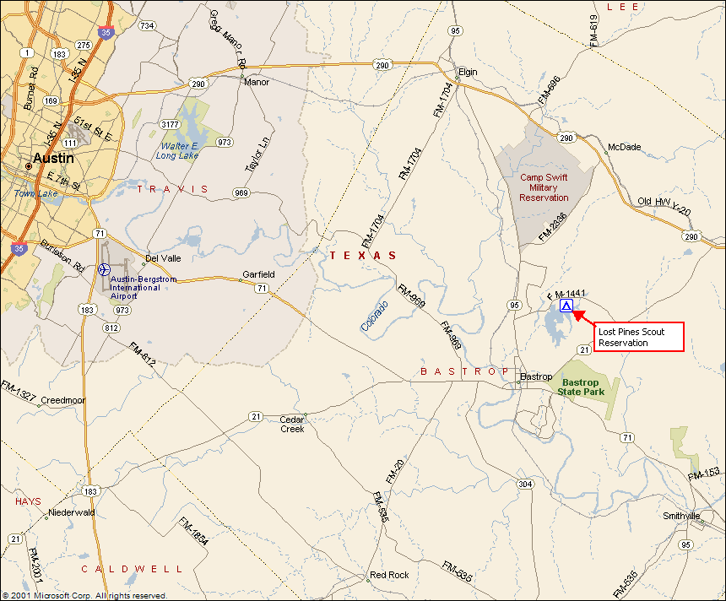

To reach Lost Pines Scout Reservation from Austin: East on Highway 290 to Elgin
South on HWY 95 for 12.8 miles
East on FM 1441 for 3.4 miles
Turn south into Lost Pines Scout Reservation

Or, if you are on the south side of Austin: East on Highway 71 to Bastrop
North on HWY 95 for 3.8 miles
East on FM 1441 for 3.4 miles
Turn south into Lost Pines Scout Reservation

Individual Scout Equipment
DRESS IN LAYERS AND BRING CAMP CHAIRS/STOOLS FOR CLASSES!

Signed Medical Report Form | OPTIONAL:  Letter Writing Material  Backpack  Chemical hand warmers  Camera & Film  Bible or Prayer Book  Work Gloves  Dirty Clothes Bag  Combination Lock  Mosquito Netting  Watch  Fishing gear (for Fishing MB)  Spending Money  Portable chair or camp stool
Scout Uniform and Belt
Socks and Scout Socks (4 or 5 pair)
Long pants (2 to 4 pair)
4 or 5 T-shirts (no tank tops)
Shoes (completely closed)
Cap or Hat (STOCKING CAP)
Underwear (including long!)
Pajamas or sleeping clothes
Sleeping Bag or blankets & sheet
Pillow
Cot or pad
Personal First Aid Kit
Poncho or Rain suit (pants & jacket)
Winter coat
Towels & washcloth
Soap and Shampoo
Toothbrush & Toothpaste
Comb, Brush & Mirror
Flashlight & Extra Batteries
Pocket Knife & "Totin Chip" card
Insect Repellent (non-aerosol)
Long sleeve shirt (2 to 4)
Sun Screen
Scouts BSA Handbook
Water Bottle (or Canteen) & Cup
Spiral Notebooks
Pen or Pencils
Completed Merit Badge Work
Survival Kit (for Wilderness Survival MB)
Whistle (if offered)
Ground Cloth
Signal Mirror
Sewing Kit
Compass
Space Blanket
Water Purification Tablets
Waterproof Matches
Don’t Bring:  Electronic items such as TV’s, gaming systems  Fireworks  Fixed blade or hunting knives | Pets  Hammocks  Personal firearms & ammunition Jewelry or other expensive items Personal bows & arrows

MARK EVERYTHING WITH SCOUT’S NAME AND TROOP NUMBER

Scouts will be outdoors or in large tents for classes and will be sitting still – not active. Winter camp weather can be quite cold and rainy or icy, so Scouts will need lots of warm clothes and layers to be comfortable. Cotton clothing (such as blue jeans) doesn’t insulate well if it gets wet and should be avoided. Nylon wind pants and jackets are useful, and with a fleece jacket and long underwear make a good combination for comfort even if it is windy and damp. Cots allow air to circulate below; a ground pad will be warmer.

Completely closed shoes are to be worn at all times unless you are in your tent or in the shower.
A combination lock may be useful to lock your valuables up in the campsite if you have a footlocker, but it is best not to bring valuables at all if possible. Personal valuables (watches, wallets, money) should never be left out in the open at camp.

Recommended Troop Equipment

Patrol Flags | Campsite entrance/gateway materials:  Troop Sign (should include Troop number)  Troop Flag  U.S. Flag  Twine & poles for lashing
Lanterns

Stove
Matches/Lighters

Dining Fly(s), poles, & stakes

Rope

Tents, poles & stakes*

Hammers & other hand tools

5 Gallon Water Jugs

Ice Chests

Trash Bags

Lockable Storage Container

Troop First Aid Kit

Compass

Shovels, Rakes, Hoes, Bow saws, loppers
Lawn chairs

Pots—coffee/water
Rolls of Surveyor’s marking tape

Fire wood (if no burn ban)
Bulletin Board:

Bulletin Board

Camp Roster

Troop Duty Roster

Scout Schedules
 | Push pins, etc. for bulletin board
Paperwork:

Troop Advancement Records

Troop Merit Badge Library

Troop’s Camping Attendance

- BSA National Standards require tents to have the warning “No Flames In Tent” marked on the outside near the door way.

Troops may also want to bring a stove to keep warm drinks available in their campsite. Hot Cider and Hot Chocolate are always enjoyed on cold days! Burn Ban and Fuel use guidelines must be followed.

Don’t forget to bring items such as thumbtacks, duct tape, vice grips, sharpening stone & oil. Check with the quartermaster or Camp Commissioners if you need anything.

Please fill out and bring a copy to turn in at camp in the medic lodge.

Medication Log
Camp Session |  | Campsite |  |  | Camp Scoutmaster
Troop Number |  |  |  |  | Address
Council |  | District |  |  | City |  | State |  | Zip
Office Use |  |  |  |  | Number of Bottles:
SCOUT’S NAME | MEDICATION  NAME/ DOSE |  | AFTER  BREAKFAST | NOON |  | 4:00 PM |  | AFTER  DINNER |  | BEFORE  BEDTIME
Please fill out and bring to Camp. Turn in during Medical re-check.

HEALTH SCREENING Staﬀ or Unit/No.
To be completed by camp director or unit leader before arrival at camp. This form will be reviewed with you by the camp health oﬃcer or designated staﬀ member at check‐in.

Please list for the camp health oﬃcer the names of campers or staﬀ who:
1. Are taking medicines currently.
2. Have special health needs that limit participation.
3. Have allergies to foods, medicines, and insect stings.
4. Have emergency medicines they keep with them.
5. Have had change in circumstances since their Health Screening was done, including:
a. Any visit to a doctor or clinic since the last exam;
b. Any recent illness, injury, rash, or allergic reaction;
c. Fever or other signs of illness or infection in the last 48 hours (i.e. nausea, vomiting, diarrhea, cold);
d. Contact with sick friends or family members in the last 48 hours;
e. Any daily medication taken 30 days prior to camp.
If any of these are present, does the person feel and look fine at present? Name Screening Notes

Unit leader signature: Date:

Leader printed name:

Texas Youth Camps Safety and Health Act FORM
Due to: BSA-CAC, 12500 North IH-35, ATX, 78753 or fax 512-926-6870 by November 30.
On April 16, 2006, the state of Texas passed into law new regulations that affect the Texas Youth Camps Safety and Health Act (Title 25, Part 1, Chapter 265, Subchapter B, Rule 265.12(f)(f1a)(f2)(g). This rule affects all licensed youth camps in the state of Texas and became effective June 1, 2006. In order for the Boy Scouts of America and the Capitol Area Council to comply with the state law on protecting our youth camp participants we must require each leader to provide the items listed below. Your understanding and assistance in this important matter is greatly appreciated.

For every adult age 18 and older who will be attending camp even for one day, each unit must provide all of the following items for that person to be able to attend camp.

This act requires all adult volunteers, 18 years and older, to undergo a criminal background check. By submitting this form, you are authorizing a criminal background check of yourself. This check will be made from public record sources. You will have an opportunity to review and challenge any adverse information disclosed by this check.

TROOP Number: CAMP WEEK:

Adult applicant FULL LEGAL name: (first, middle, last)
Address: Date of Birth:
City,ST Zip: Day Phone:
Email:
Signature: Date:

Please Answer the Following Questions
Do you use illegal drugs? | YES | NO
Have you ever been convicted of a criminal offense? | YES | NO
(If yes, explain on back of page)
Have you ever been charged with child neglect or abuse? | YES | NO
Has your driver’s license ever been suspended or revoked? | YES | NO
(If yes, explain on back of page)
Other than the above, is there any fact or circumstance involving you or your background that would call into question your being entrusted with the supervision, guidance, and care of youth? (If yes, explain on back of page)

Character references: Contact phone:
1.
2.
3.

Submit this form to Capitol Area Council by November 30 via mail, fax or email to: 12500 North IH-35, Austin, TX 78753 or 512-926-6870 fax or 564roster@scouting.org

OFFICE USE ONLY
Date received Date approved

Date application sent to Camp Director

Approved by _Title

Capitol Area Council Campership Assistance
Campership Assistance Request
How this Program Works:
Camping is one of the methods of delivering the Scouting Program. The Capitol Area Council wants to make sure every Scout has an opportunity to have a mountain top experience at camp. Please be aware that additional assistance is usually available through the Scout’s Unit and Chartered Organization and that these resources should be asked before applying for a campership. All Scouts who receive campership aid should earn or provide part of their fee, in keeping with “A Scout is Thrifty”. After completing the Assistance Request, submit it to the Council Event Coordinator who will have it reviewed. If approved the Scout family will be provided up to 50% of the cost of camp (subject to availability and budget).
This program has limited resources and availabilities:
To help ensure that we continue to receive financial gifts to keep these programs possible, you are asked to include a brief letter with your assistance request that can be shared with possible donors. We ask that this letter be from the Scout and include what Scouting means to them and how attending this camp will have an impact.
Contact Information
Scout’s Name: __________________________________ Scout’s Rank: _________________ Scout’s Unit: ____________
Family Contact Person: _____________________________________ Contact Phone: _______________________ Contact Email: _____________________________________________________

Scouting Background
When did this Scout earn their last rank advancement? ________________________________________
Did this Scout attend camp the previous summer? ________________________________________
Did this Scout participate in the most recent Council Popcorn Sale? ________________________________________
Are other family members registered in Scouting? (if so, who) ________________________________________
Has this Scout received a campership in the past? (if so, when) ________________________________________

Camp Information (check one)
[ ] Cub Scout [ ] Webelos [ ] Scouts, BSA [ ] NYLT [ ] Hornaday [ ] Wood Badge (adult)
Please indicate camp type (day, summer, winter, etc.) _______________________ Camp dates: _____________________
Assistance Needs
Total Annual Household Income (from all sources): _____________ Total Number of Household Members: _____________
Does the Family receive free or reduced price school meals? Yes No (Circle One) How Does the Scout plan to fund Camp?
Family/Scout Contribution $_____________ Unit/Chartered Org Contribution $______________ Requested Amt $______________
A Scout is Trustworthy, The above information is True, Scouts Honor.
Parent/Guardian Signature: ________________________________ Date: __________________________
Council Event Coordinator Signature: ________________________________ Date: __________________________

For Official Use Only
___ Unit asked to help with camp ___ Scout currently registered
___ Chartered org asked to help with camp ___ Scout active in programs
___ Date received ___ Personal letter attached
Assistance Committee Recommendation ____________________________________

