Lost Pines Scout Reservation

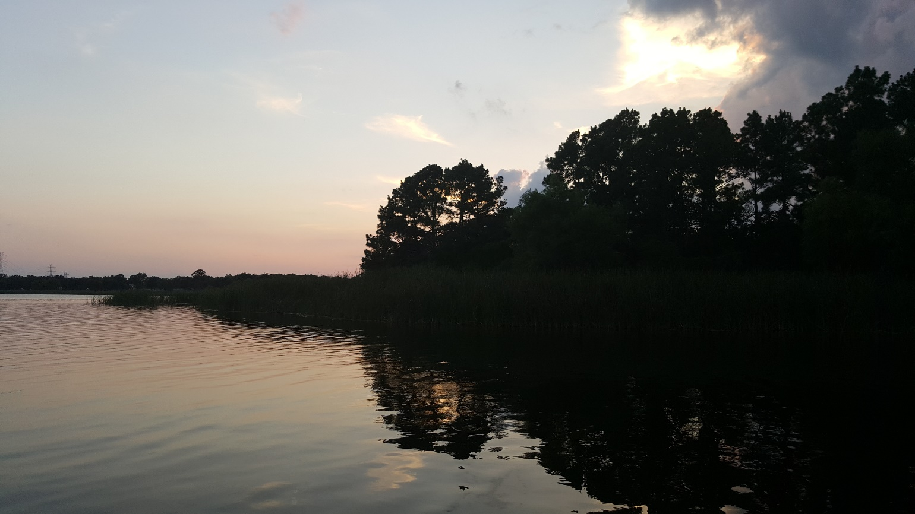

Summer Camp
2020 Leader’s Guide

Version 1-23-20

Table of Contents

Introduction 4
Camp Telephone & Address 4
Preparing for Camp 5
Register Your Troop 5
Requesting Camperships 5
Select Merit Badges 5
Recruit Adults 5
Collect Current Medical 5
Dietary Needs 6
Conduct Swim Checks 6
Provisional Scouts 6
Out-of-Council Units 6
Changes to Your Reservation 6
Refund Policy 6
Arriving at Camp 7
Unit Check-In 7
Medical Recheck: 7
Vehicles 7
Sharing Campsites 8
Merit Badge Class Changes 8
Flag Retreat/Dinner 8
Troop Cracker Barrel 8
Monday Arrivals 8
During Camp (Campsite, Policies, Resources) 8
Conduct Policy 8
Uniform and Shoes 8
Camp Commissioners 9
Honor Troop 9
Honor Campers 9
Tonkawa & Scoutmaster Challenges 9
Your Campsite 9
Model Campsite 9
Patrol Camping Areas 10
Bathhouse Cleaning 10
Bicycles & Helmets on Camp 10
Fires & Fuels 10
Tobacco, Alcohol, Drugs, Fireworks, Firearms, Knives & More 11
Tools 11
Visitors 11
Lost and Found 11
Camp Staff Area 11
Trading Post 11
Adults During Camp Week 11
Coffee & Internet 11
Volunteer 12
Adult Training 12
Adult Leader Meeting 12
SPL Meeting 12
Health and Safety 12
Medications 12
A Scout is Reverent! 13
Grace 13
Chapel Service 13
Camp Chaplain 13
Schedule Overview 13
Program Areas 13
Evening Activities 13
Troop Swim 13
Dining & Diet 13
Daily Schedule 14
Evening Schedule 14
Order of the Arrow 15
At the End of Camp 16
Merit Badge Completion Report 16
Family Night Dinner 16
Checkout Process 16
Merit Badges, Activities, Programs Schedule 17
Aquatics - Pool Activities 20
Aquatics - Waterfront Activities 21
Living History 21
Shooting Sports 23
Nature-Environment-Conservation (Nat-E-Con) 24
Scoutcraft 25
Eagle Quest – First Year Camper Program 27
Climbing 28
Scuba Merit Badge 28
ATV Safety Course 29
Silver Pines Adventure 29
Leader Training Options 29
Summer Camp Checklist 30
Map to Lost Pines 32
Lost Pines Camp Map 33
Individual Scout Equipment 34
Troop Equipment 35
Texas Youth Camps Safety and Health Act FORM 36
Pre-Camp Swim Check 37
Medication Log 38
Medical Screening 39
Campership Assistance Form 41

Welcome to Lost Pines Scout Reservation, your 2020 Summer Camp Adventure! Lost Pines Scout Reservation has served the Boy Scouts of America for over 50 years and we look forward to providing your troop with a fun and memorable camp experience. We have many exciting programs and over 45 merit badges from which your Scouts can choose. In this guide you will find all the information you’ll need to know in order to plan for your merit badges and evening programs for the best possible experience.
We, the Staff at Lost Pines, believe it is our mission to provide an environment where all Scouts have fun while developing character, citizenship and personal growth. Through the use of the patrol method, Scouts will learn about themselves and come away with a sense of being the best possible patrol leader, troop member and individual.

Lost Pines strives to provide an excellent quality program and will continue to make improvements to the program. We search to find the highest quality staff members who have knowledge and experience in their fields. Out enthusiastic and well-trained staff is here to assist you from the time you arrive until the time you leave. Thank you again for choosing Lost Pines Scout Reservation for your summer camp experience.

Yours in Scouting,
Toni Nelson
Camp Director
Txtoni13@gmail.com
512-736-2806

Important Dates |  | Total Fees
April 1 | First Camper Payment ($170 per scout, $80 adult) | Youth - $340  Provisional Youth - $360
April 15 | Campership Applications Due | Adult - $160  Adult Partial Week - $30/day
May 1 | Final Payment Deadline ($145/scout, $80 adult)  Merit Badge Sign-up Closes  Tent Rental Requests Due Adults Identified by Name and Entered in DoubleKnot  Adult Forms Due (TX Youth Camps & YPT) | Scuba - $300 youth; $375 adult  Silver Pines - $60
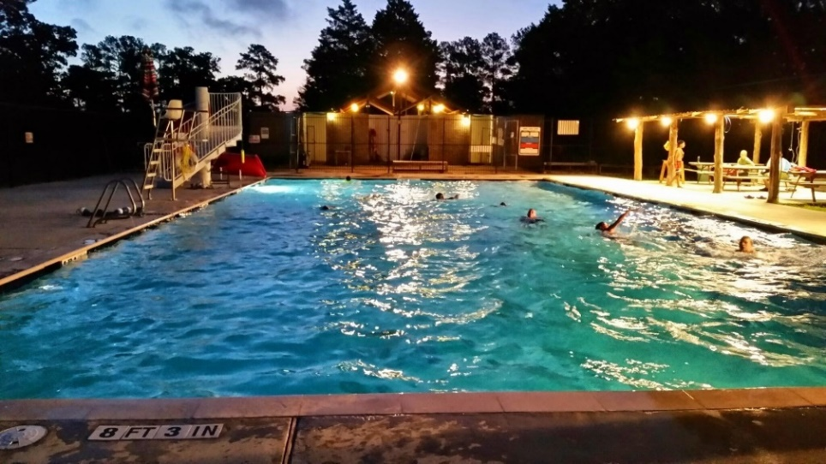

Lost Pines Scout Reservation
785 FM 1441
Bastrop, TX 78602
512-303-0768
Preparing for Camp
Register Your Troop
ALL Troops must submit a Summer Camp Reservation Form (https://www.bsacac.org/activities/summer-camp/) or contact Keri Smeaton at the Council office at 512-617-8610 or keri.smeaton@scouting.org to reserve your week and pay your deposit. The deposit is $25 per scout estimated in attendance and is non-refundable. Please make sure you are not overestimating the number of scouts attending. Reservations will not be processed without the deposit. Please be sure to include check or credit card information with the reservation form.

Be aware that while you have the option of choosing a site with tents for an additional charge, Lost Pines does not provide cots or other sleeping materials.

Once your Troop has been registered, your Troop designee will be given the necessary access and instructions to enter the names of those Scouts and adults attending camp.

Submit First Payment ($170 per scout) by April 1

Request Camperships by April 15
A limited number of camperships are available each year for Scouts that have severe hardships. Troops should encourage Scouts to earn their own way through unit fundraisers. Camperships cover up to 25% of the camp fee during weeks 1-3 and up to 50% during weeks 4-5. Please use the campership application (https://www.bsacac.org/wp-content/uploads/2019/05/camperhsip_assistance_form.pdf) to apply. This application must be submitted to the Council by April 15.

Select Merit Badges for Your Scouts by April 30
Use the “Merit Badges, Activities, and Programs Schedule” of this book to help determine course schedules for each of your Scouts. Please pay special attention to age requirements, prerequisites and requirements that will not be completed at camp. Be sure to register for merit badges early as some classes fill up quickly! You can select courses in DoubleKnot until May 1. After that, all requests must be emailed to the Registrar.

Recruit Adult Leadership and Submit Forms by May 1
At least two over 21 adults are required for all units. Female troops must have at least one female adult over 21 years of age. ALL adults attending camp and staying overnight with a troop must comply with the following:
- Complete Youth Protection Training online (YPT Aging Report from my.scouting.org preferred or YPT Certificates);
- Complete the Texas Youth Camps Health and Safety Act Form (part of your DoubleKnot adult registration or online at http://www.bsacac.org/formssummercamp.php); and
- Provide proof of BSA membership (Troop roster from my.scouting.org preferred or BSA Membership Cards).
To make your check-in process as quick as possible at camp, submit the necessary adult forms to Council at 564roster@scouting.org no later than May 1. Texas state law requires that background checks be run BEFORE you arrive on camp.

**NEW** If your adults are only coming for part of the week, they will need to register as “Adult – Partial Week”, even when switching with other adults. This will allow us to plan appropriately for dining hall seating as well as provide camp mugs and patches for all adults on camp.

Submit Final Payment by May 1

Collect Current Medical Forms Early & Prepare Binder for Check-In
Every Scout and Adult attending camp will need a completed BSA Medical Form parts A, B and C with a physician signature dated within the last 12 months. Note that Part C requires a Tetanus booster within the last 10 years. You will need to turn these in to the Camp Health Officer at check-in. Make a copy of all forms, leave the original at home and bring all forms in a binder alphabetized with scouts in front and adults in back.
Plan for and Communicate Dietary Needs
Lost Pines strives to provide options to fit a number of dietary needs with every meal. Upon request, we can provide gluten free and vegetarian options. When registering, please be sure to indicate if members of your Troop will require gluten free or vegetarian meals. We do acknowledge that we cannot accommodate some dietary needs. For those instances, microwaves and refrigerators/freezers are available in the back of the Dining Hall for camper and leader use.

Conduct Swim Checks Ahead of Time
BSA requires that ALL Scouts and adults wishing to participate in aquatics activities have completed a Swim Test within the last 12 months. While we will offer these at camp check-in, you can save yourself time by completing this ahead of time. Use the form found at https://www.bsacac.org/my_files/pre_camp_swim_check.pdf and bring it to turn in during the check-in process at camp. Be sure your test administrator signs the form and enters all necessary information.

Provisional Scouts

While it is preferred that Scouts attend summer camp with their Troop, we recognize that there are Scouts who would like to come to Lost Pines when their Troop doesn’t attend. They could be Scouts unable to attend with their troop because of other commitments, or Scouts returning for a second time during a summer.

We will accommodate these Scouts during weeks 3-6 as Provisional Scouts by placing them with other provisional scouts and a staff member(s) who serves as the Scout Master(s) for the week. They will have their own campsite with platforms and tents.

Provisional Scouts must register through Keri Smeaton, keri.smeaton@scouting.org. A $100 non-refundable deposit is required at the time of registration. The fee for individual (Provisional) Scouts will be $360. If a parent is attending camp with a provisional Scout, the $160 leader fee will apply. Provisional Scouts must submit proof of membership at time of registration (either a current BSA membership card or Troop roster from my.scouting.org).

Troops who cannot meet the two-adult minimum requirement are encouraged to partner with another troop in advance to meet this requirement. Notify the Council when registering for camp so that we can insure both Troops are placed in the same campsite. When 4 or more Scouts from the same unit are wanting to camp as a Provisional Troop, adult leadership is expected, and registration may be denied.

Special Note for Out-of-Council Units
All registered members (youth and adult) of the Capitol Area Council are covered by the Council accident and sickness insurance policy. Out-of-Council units must provide proof of insurance at check-in. Your home Council should be able to provide guidance on obtaining this information.

Changes to Your Reservation
Please contact the Council office for availability should your attendance numbers change from your initial reservation estimate. NEW SCOUTS who join your troop after the April 1 reservation deadline must pay as soon as possible. Balances are still due by the final fee payment date. Should your Troop have a decrease in the number of Scouts who will be attending camp between April 1 and your final payment date, May 1, please notify the Council office.

Refund Policy
For the Council’s full Refund Policy please go to https://www.bsacac.org/refund-policy/.

The Campsite Reservation fee of $25 per scout is not refundable if the Troop does not come to camp. For troops that do come to camp, it may be applied to the balance for this summer’s camp fees.
Arriving at Camp
Camp check-in begins at 1pm on Sunday afternoon and Troops are asked to arrive before 3:30pm. We ask that you view our check-in video at https://youtu.be/5iAgi63mwZ8 for an overview of the check-in process and how to make it faster and easier for your unit.

Upon arrival at camp, please park all vehicles in the designated lot. Staff will be available to escort your Troop’s trailer to your campsite or assist in transporting gear for Troops without a trailer

The Troop must report to Lindsay Lodge for troop check-in and medical check-in.

At Lindsay Lodge, there will be an easily identifiable camp staff member who will connect your Scouts with their Camp Troop Guide and direct the adult leaders to the appropriate location. You will have the option of (a) leaving your Scouts outside Lindsay with their Troop Guide(s) or (b) allowing the Troop Guide(s) to take them on a camp tour while you complete the check-in process.

If you have two adult leaders, you can speed up the process by having one handle the unit check-in and one do the medical recheck.
- Unit Check-In: Conducted in Lindsay Lodge, this is a multi-step process where you will do the following:
  - Verify all adult leader forms (TX Youth Camps form, YPT completion and BSA membership)
  - Verify camp attendance versus registered and dietary restrictions (gluten free, vegetarian, no pork, no beef only)
  - Pick up your check-in packet which contains wristbands to be worn at all times and other valuable camp information
  - Provide on-site adult leader contact information
  - Sign-up for flag ceremonies, grace before meals and Scout’s Own worship service
  - Turn in swim check forms
  - Sign up for Climbing Instructor Training
- Medical Recheck: Conducted in the Health Lodge adjacent to Lindsay Lodge, you will need to provide the following:
  - Medical Screening Form
  - Medical Forms: Anyone staying on camp must have the BSA Medical Form parts A, B and C with a physician signature within the last 12 months (please note that school physical forms do not meet the BSA requirement and cannot be accepted). The troop is encouraged to bring medical forms in a three-ring binder with two sections. Scouts’ forms should be in alphabetical order in the first section and adult leaders’ forms in alphabetical order in the second section.
  - Medication Log for your Troop. All medications must be managed by an adult leader. You will also be asked to verify the medications will be stores behind two locks, as per BSA requirements.
  - Any Scouts/adults with Epi-Pens or inhalers will need to see the medic at this time.

Following check-in, if not already done, a staff Troop Guide will take your Troop on a camp tour of the main camp area. The tour will include the Dining Hall where the Scouts will learn of their assigned table they will be responsible for during the week, how to enter for meals and receive their water bottles (youth) and mugs (adults). Please bring these bottles to every meal as camp does not provide cups in the dining hall.

Vehicles
NO vehicles will be allowed in the campsites. You may park one trailer with attached vehicle outside your campsite as identified by the camp. If you require assistance in transporting gear into your campsite, please make a request during check-in.

Sharing Campsites
All Troops should expect to share their campsite with another Troop. Please be courteous and do not take over the entire campsite including fire rings, picnic tables, pavilions and tents.

Merit Badge Class Changes
There is an opportunity after check in Sunday to make changes in your Scouts’ schedules. Remember, some merit badges may no longer be available.

Flag Retreat/Dinner
All troops should report to the parade ground flagpole by 5:40pm in Class-A uniform for the formal flag retreat and any announcements. Troops are released from the flag assembly one at a time to go to the dining hall for dinner. Please make sure your Scouts walk from the flag assembly to the dining hall!

Troop Cracker Barrel
At 8pm on Sunday your Troop Guide will bring snacks to your campsite to participate in cracker barrel with your unit. They will have information to share regarding breakfast, mile swim, adult leader training, patrol challenge and other events taking place during the week. They will also meet with your SPL and SPLs of the other units assigned to your bathhouse at 9pm to go over your unit’s responsibilities for cleaning and restocking the bathhouse. For more information on bathhouses, see the Bathhouse Cleaning section below.

During Camp Week – Campsite, Policies and Resources

Conduct Policy
The conduct and discipline of the youth in your troop are YOUR responsibility. Please be vigilant in making sure your scouts’ behavior is consistent with the Scout Oath and Law. This is a camp policy that we have found to be of mutual benefit. The camp staff will not discipline your scouts unless it is a case of imminent bodily injury or property damage.

Your campsite is your home. Entering or loitering around another campsite without that troop's permission invites problems. Raiding of campsites or staff areas by campers or staff is not permitted. Taps is at 10:30pm. All campers are expected to be in their own campsite by that time. Troop activities such as night hikes, astronomy, etc., are encouraged and would constitute an exception. These activities must have appropriate adult supervision. Youth campers found outside their own areas after 10:30pm will be escorted back to the campsite by a staff member.

Please abide by the outdoor code while at camp. Do not cut or mar trees. Help your Scouts know the importance of caring for trees and all property. Capitol Area Council prohibits the use of hammocks on all of our properties including Lost Pines Scout Reservation. We appreciate your cooperation.

Uniforms and Shoes
The official Scout field uniform is to be worn properly by Scouts and adult leaders at flag retreat and dinner. NOT PERMITTED are caps, T-shirts, etc., with words or pictures not representing the best spirit of the Scout Oath and Law. For safety reasons, closed shoes (sneakers or boots) are to be worn at all times (except in your tent, at the pool, or in the shower). Please, no Crocs or hiking sandals. Also, a shirt with sleeves must be worn at all times except during aquatic program time. Swimsuits should be one-piece, or tankinis that cover the midriff, no bikinis.

Camp Commissioners
One of the most important resources at camp is the Camp Commissioner staff. They are experienced Scouters who have volunteered their time to assist your Troop during your summer camp adventure. They will be available to answer questions and to help coordinate the various activities during the week. Camp Commissioners are a tremendous resource – if you need help with anything, please don’t hesitate to ask them!

Honor Troop
Honor Troop awards are presented Friday night at the closing campfire. Criteria for achieving the Honor Troop award will be determined by the Camp Commissioners during SPL & Scoutmaster meetings. The primary criteria for earning the Honor Troop designation is the score achieved on the daily campsite inspection. It is recommended that the Troop’s daily score be posted on the Troop bulletin board and/or announced during Troop meetings. Scoring criteria will be available on the summer camp page and will be provided at check-in.

Honor Campers
The youth and adult leaders of each troop select the Honor Campers for their patrols near the end of the camp week. These campers should exemplify Scout spirit and positive attitude and should stand out from the other Scouts in the troop. Completion of the Tonkawa Challenge might be considered to be the baseline of all Honor Campers. The maximum number of honor campers for each troop is one per patrol (recognition is a certificate).

Tonkawa Challenge & Scoutmaster Challenge
The Tonkawa and Scoutmaster Challenges are designed to give all at Lost Pines a rounded camper experience. A distinctive patch will be awarded to each Scout submitting the checklist for Tonkawa Challenge, and each adult submitting for the Scoutmaster Challenge by Friday 2pm. Patches will be placed in the Troop’s check-out packet.

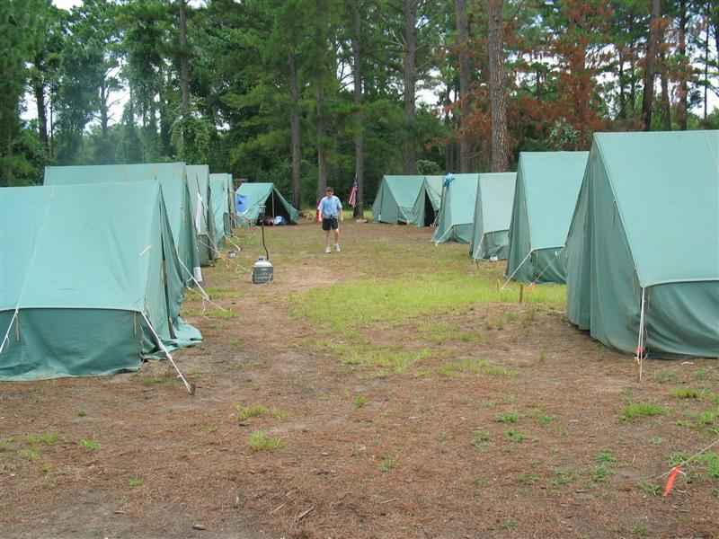
Your Campsite
The Troop’s campsite arrangement and orderliness reflects upon the Troop’s standards. Living in a clean and well-organized site helps a Scout feel pride in themselves and Scouting.

Listed below are aspects of a well-established troop campsite. In addition, all tents must be clearly marked with “NO FLAMES IN TENTS” labels or signs. A Camp Commissioner and other troop leaders will visit you and your site during the week. The Commissioner may share ideas with you about ways to improve your site. For your troop to win the Honor Troop award, your campsite should possess the attributes of a model site.

Model Campsite Checklist
- U.S. and Troop flags displayed with troop identification
- First aid kit available in a central location
- Campsite laid out with clear and safe traffic lanes
- Tents and flies pitched correctly, taut and using proper knots
- Tents marked with “No Flame in Tent” sign or stencil
- Campsite clean — litter free; personal items stored, surfaces clean
- Trash bags emptied regularly (place in designate spot outside your bathhouse)
- Bulletin board with roster, fireguard chart, emergency procedures, schedule & program information posted
- Assigned bathhouse cleaning schedule
- Saw/axe yard separated from central site, marked, and adequate size (optional)
- Patrol flags or other markings so patrol areas are clearly identifiable

Patrol Camping Areas
MAKE PATROL CAMPING AREAS. Your campsite is your home for the week so make it comfortable by bringing banners and flags to dress it up. Baden-Powell once said that the patrol was the secret of success in Scouting. There must be certain activities for which the patrol has complete responsibility such as camp craft, contest practice, camp improvement, hiking, basic instruction and troop activities. Leadership development and an increase in Scout spirit are positive results from the use of the patrol method.

Bathhouse Cleaning
The campsite your Troop is in determines which bathhouse you will use and are responsible for keeping clean. The chart below shows a sample of the bathhouse assignment you will receive at check-in. Troops are responsible for cleaning both the youth and adult sides of the bathhouse in the morning and afternoon. When sharing a time slot, ask the Senior Patrol Leaders to meet and coordinate cleaning. Instructions are posted at each bathhouse inside the supply closet.

SAMPLE - Campsite Bathhouse Assignments
Bath-house | Sunday PM | Monday AM | Monday PM | Tuesday AM | Tuesday PM | ETC…. | Sat
#1  Wilmot Freedom | T1, T4, T6 | Prov, T3, T7 | T2, T5 | Prov, T3, T7 | T1, T4, T6 | T2, T5 | All
#2  Fish  Kitchens | T101, T104, T106 | T103, T107, T119 | T102, T105 | T101, T104, T106 | T103, T107, T119 | T102, T105 | All
#3 Beis. Kaspar Turner Dacy | T201, T204, T206 | T203, T207, T219 | T202, T205 | T201, T204, T206 | T203, T207, T219 | T202, T205 | All
#4  San Gab Lindsay Gaskin | T301, T304, T306 | T303, T307, T319 | T302, T305 | T301, T304, T306 | T303, T307, T319 | T302, T305 | All
Smith | T457 | T454 | T450 | T457 | T454 | T450 | All
If repairs are necessary in the bathhouse, please inform the Camp Commissioners. If damage from vandalism occurs, your Troop is financially responsible for the cost of repairs. This cost will be allocated between the Troops assigned to the bathhouse.

Bicycles, Scooters, Skateboards, Hoverboards, etc. and Helmets on Camp
Bicycles with helmets are permitted on camp roads only. Rider must wear a helmet and proper clothing at all times and yield the right of way to individuals who are walking. If you plan to ride after dark, your bicycle must be equipped with a working headlight and red tail light. Individuals with bicycles are responsible for following Bicycle Safety as outlined in Guide to Safe Scouting. While Lost Pines will provide bicycles for those taking the Cycling merit badge, we do not rent bicycles at camp. For the safety of all, we do not allow scooters, hoverboards, skateboards or similar wheeled items at Lost Pines, unless medically necessary.

Fires & Fuels
Ground fires are permitted during Summer Camp in a fire ring IF a burn ban is not in place. If your unit wishes to have a fire, the Troop Leaders must complete the Ten Steps to a Safe Fire form (available in the A Building) and have it and your Unit Fireguard form posted in the campsite.

Liquid or propane fuels are to be used only under adult supervision and must be stored under lock and key. Liquid fuels cannot be used on open fires or to start a fire. National policy prohibits the use of open flames in tents. This includes mosquito coils, catalytic heaters, gas lanterns, stoves, candles, and smoking materials.

Tobacco, Vapes, Alcohol, Illegal Drugs, Fireworks, Firearms, Knives and More
Adult leaders should not allow the use of tobacco/vape products at any BSA activity involving youth participants. In addition, tobacco use in the presence of Scouts is not permitted at camp. Adult Leaders wishing to use tobacco products or vape may do so only in the Commissioners Area. The consumption, possession, or use of any alcohol, illegal drug or controlled substance is strictly forbidden on any Capitol Area Council property. We will enforce all local, state, or federal laws where violations involving the above are reported. Fireworks, pets, personal firearms and ammunition, and personal bows and arrows, of any type are not allowed at camp. In addition, camp policy prohibits the carrying of fixed-blade knives except for the purposes of OA ceremonies and Living History night. Do not take home any wild animal. Pets of any kind are not allowed on camp unless they are a service animal. Violators will be asked to leave camp.

Tools
Camp Commissioners have an assortment of tools for your use as well as a list of available service projects. Check them out when you need them and return promptly after you have finished with them so others can use them. All equipment checked out to your Troop must be returned or paid for before you leave camp.

Visitors
All visitors to camp must check in at A Building immediately upon their arrival at camp. Anyone staying overnight will need to provide proof of BSA membership, Youth Protection Training certificate and TX Youth Camps form as well as a completed medical form.

Lost and Found
Lost and found will be kept in Dining Hall, Pool and A Building. Friday morning all lost and found will be moved to the porch of A Building. Please take only what belongs to you from lost and found area. Unclaimed items will be kept at the Fickett Center for 30 days before being donated to a charitable organization.

Camp Staff Areas
Scouts are not allowed in the camp staff area at any time. We ask Troop leaders to help enforce this policy.

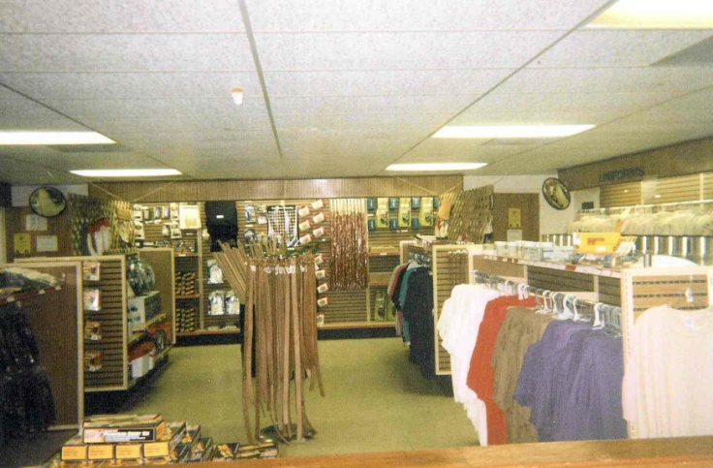
Trading Post
Ask your Scouts to use discretion when buying drinks and candy at the Trading Post. Please help us keep the drink containers, papers, and trash picked up. Various handicraft kits and supplies are offered along with T-shirts, mugs, and literature such as handbooks, and merit badge books. The Trading Post accepts major credit cards.

Bags and blocks of ice can be purchased at the Administration building using the ice tickets received at check-in or for $2 per bag/block.

Adults During Camp Week
BSA policy requires two adult leaders over the age of 21 be on camp at all times (leaders may rotate if necessary). Visit classes periodically to observe your Scouts. Check your mailbox in the A-Building every morning and afternoon for status updates on your scouts as well as any mail you may receive.

Watch your Scouts for dehydration. If they get headaches, homesick, or aren’t hungry – make them drink water. They are very likely to be dehydrated. Scouts should be drinking at least 8oz of water per hour.

Coffee & Internet
With coffee always on and wifi readily available, adult leaders can congregate in the dining hall for refuge and a chance to catch up on some of the paper work as well as to socialize with other leaders.

Volunteer
Each adult leader who comes to camp brings special skills or teaching abilities that can benefit the camp program. If you can assist in teaching or want to instruct a merit badge, please talk with the Program Director on Sunday. Or, if you are a carpenter, electrician, plumber, or handyman, our camp can sure use your skill during the week. Bring your tools and feel as if you're still at home! Check with the Program Director or Camp Director at check-in or any time during the week.

Adult Training
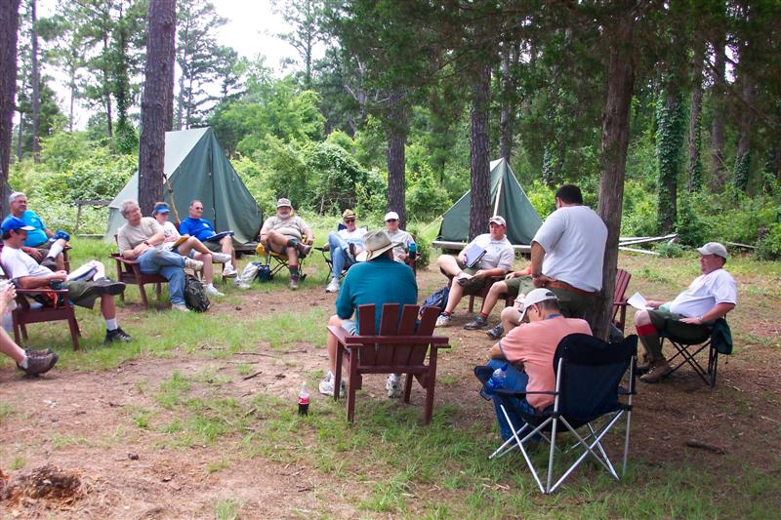
Each week, classes including Safe Swim Defense, Scoutmaster Position Specific, Introduction to Outdoor Leader Skills, Troop Committee Challenge and First Aid/CPR are taught to Scout leaders. The exact offerings will vary based on trainer availability. If you are interested, please consult the adult training schedule provided at check-in or ask a commissioner. Leaders may use their troop swim for practical Safe Swim Defense experience. They can also complete the Mile Swim or take BSA Lifeguard.

Adult Leader Meeting
Adult Leader meetings are held daily at 10am in the Dining Hall. This meeting provides the Troop leadership the opportunity to discuss upcoming activities, sign up for various activities, problem solve, and learn more about summer camp at Lost Pines. It is very important that one or more adult leaders from each Troop be present at this daily meeting. If possible, all adults should attend this meeting.

During this meeting, you will be asked to provide head count for Tuesday night Adult Leaders dinner and Friday Family Dinner. It is important for us to have these numbers in advance to insure we have enough delicious meals available.

SPL Meetings
Make sure your SPL (or his designee) attends the daily Senior Patrol Leaders Meetings. This meeting takes place in the Commissioner’s Area at 1pm. This meeting serves to provide SPL’s with the information they need regarding campsite inspection, changes to the camp program, and other information. It is mandatory that each Troop be represented at this meeting each day.

.
Health and Safety
The Health and Safety of the Scouts and Scouters is a primary consideration at Lost Pines. We provide a Health Lodge staffed with one or more persons trained to handle minor accidents or illness. Special arrangements for the treatment of more serious cases have been made with physicians in Bastrop.

In the event such treatment is required, the camper's parents will be notified by telephone giving the nature of the emergency and their desires concerning further treatment. It is the responsibility of Troop leadership to provide transportation for troop member(s) to a doctor or hospital. Two adults from the troop should accompany the troop member(s) to the doctor or hospital and are asked to take insurance forms with them. The leader must obtain the injured Scout’s health record from the Health Lodge before going to the doctor or hospital. The camp will provide transportation only when a troop has none available. Directions to doctors’ offices and hospitals are available at the Health Lodge.

Medications
Medications to be taken at camp must be controlled by the unit leader. All medications must be in the proper original containers labeled with the patient’s name, medication name and written dosage directions. Unit Leaders must have the Medication Log found in the appendix filled out and turned in at medical recheck. Adults MAY dispense medications to boys in the troop but must NEVER allow medication to be in the possession of a scout. The only exceptions are epi pens and inhalers which the scout is trained on and needs for extreme emergencies.
A Scout is Reverent
Grace
During check-in, Troops will be asked to volunteer to lead the camp in grace before meals: after evening flag ceremonies or in the Dining Hall line before breakfast is served. The Lost Pines Grace or the Philmont Grace is always appropriate, but other graces may be used if they are appropriate for the variety of religious beliefs that are present. If you have any questions, you may check with the Camp Chaplain, the Program Director or Camp Commissioners.

Scout’s Own Service
Please encourage Scouts to attend the Scout’s Own Service, held Wednesday at 5:15pm in the camp Chapel, near Fish campsite. If your Chaplain’s Aide or other Scouts wish to participate in the service, please contact the Camp Chaplain at check-in. All are welcome to attend.

There will be a Chaplain on call during the week to assist units with issues including homesickness, and in selecting appropriate graces for meals.

Schedule Overview
Program Areas
Merit Badge and related activities at Lost Pines are designed to fit into a five-day schedule. Classes are held in four sessions in the morning with three more sessions in the afternoon Monday through Thursday. Friday afternoon there will be camp wide activities for all Scouts.

Evening Activities
There are a variety of evening activities. On Sunday night, our staff will join you in your campsite for Cracker Barrel. Monday is Adult shoot. Tuesday is Adult Leader dinner and Living History night. Wednesday is Action Archery. On Thursday, we have the Staff versus Scoutmasters volleyball game as well as the Order of the Arrow ice cream social (open to all Order of the Arrow members). Friday evening is the closing campfire on T-Bird Island.

Troop Swim
Each Troop will have the opportunity for a “Troop Swim”, by campsite. You will share the pool with other troops. To participate in Troop Swim you must complete Safe Swim Defense training which is offered on Monday at 1:15pm in the Dining Hall. This training will layout ground rules for safety and determine leadership for each session. The Troop must provide an over 21 adult as well as additional designated lookouts for every ten swimmers. It is recommended that you meet with the leaders of other Troops that are swimming with you after the meeting to coordinate. Camp will provide one Aquatics staff member to assist with facility question. Please let the Aquatics Director know if you do not plan to take advantage of the troop swim. Your troop swim will conflict with other activities; and each unit will have to prioritize their time in this regard.

Troop Tower
Each Troop will have the opportunity for a “Troop Tower Night”, by campsite. You will share the tower with other troops.

Dining & Diet
Meals are served cafeteria style in our air-conditioned Dining Hall. To avoid crowding, your troop will have an assigned table(s). Menus will be posted to the summer camp page and should be reviewed for possible allergies. A refrigerator/freezer and microwave will be provided for individuals with special dietary needs. Food should be in Ziploc-style bags labeled with individual’s name and Troop number. All Scouts must be accompanied by an adult when getting food in the kitchen area.

Daily Schedule
Time | Activity
7:00 am | Breakfast
7:45 am | FLAG CEREMONY – all troops
8:00 - 8:50 am | 1st class period – Mon. - Thur. | Friday-Make-up time
9:00 - 9:50 am | 2nd class period – Mon. - Thur.
10:00 – 10:45 am | Leader Meeting
10:00 – 10:50 am | 3rd class period – Mon. – Thur.
11:00 - 11:50 am | 4th class period – Mon. - Thur.
12:00 pm | Lunch
1:00 - 1:30 pm | SPL Meeting
1:45 - 2:35 pm | 5th class period – Mon. – Thur. | Friday-Camp wide fun
2:45 - 3:35 pm | 6th class period – Mon. – Thur.
3:45 – 4:35 pm | 7th class period – Mon. – Thur.
4:35 - 5:20 pm | Open time (pool, shooting sports, waterfront, handicraft areas open all week, tower open Tues & Thursday)
5:45 pm | FLAG CEREMONY – all troops
6:00 pm | Dinner
7:00 pm+ | Evening Programs
10:30 pm | Taps — LIGHTS OUT
Evening Schedule
Day | Time | Activity
SUNDAY | 1:00 pm  8:00 pm | Merit Badge Course Changes (Scouts with their leader)  Campsite Cracker Barrel with Troop Guide
MONDAY | 7:00 – 9:30 pm  7:00 – 8:30 pm  7:30 – 9:30 pm  9:00 pm | Open Tower & Troop Swim (two sessions)  Adult Leader’s Action Archery Training at Archery Range  Adult Leader’s Open Shoot at Rifle and Shotgun range  Movie Night  Eagle Quest Overnighter meet at Eagle Quest
TUESDAY  (Camp t-shirt day) | 6:00 pm  7:00 – 9:00 pm  8:30 – 10:00 pm  9:00 pm | Adult Leader’s Dinner in Dining Hall  Living History Night  Troop Swim (one session)  Astronomy Night
WEDNESDAY | 5:15 pm  7:00 – 10:00 pm  7:00 – 9:30 pm  7:00 – 9:00 pm  9:00 pm | Scouts’ Own Service at Chapel  Troop Swim (two session)  Nat-E-Con Night; Tower Night  Action Archery  Wilderness Survival Overnighter Meet at A Building
THURSDAY | 6:00 am  7:00 pm  9:00 – 10:00 pm | Scuba meet in Dining Hall  Volleyball Challenge: SPLs vs. Staff, Scoutmasters vs. Staff  O.A. Brotherhood Ceremony & Ice Cream Social O.A. Members
FRIDAY | 6:00 am  1:30 – 4:30 pm  6:00 pm  8:00 pm | Silver Pines, Scuba, Cycling meet in Dining Hall  Patrol Challenge  FAMILY DINNER  Closing Campfire
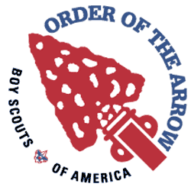
Order of the Arrow Tonkawa Lodge No. 99

OA Members in Camp
All OA members are encouraged to pack their OA sash right next to their Scout spirit of cheerfulness and service and bring it all to camp! During Summer Camp at Lost Pines Scout Reservation, the Order of the Arrow has several duties and activities. Primarily, they run and facilitate inductions and act as an information link into Tonkawa Lodge for visiting units. They also provide units with the knowledge they need to help their OA members grow into quality youth leaders through the Order.

Ice Cream Social
Thursday night is the Order of the Arrow ice cream social. During this time the OA members on staff will give a quick synopsis of the OA’s programs and exciting upcoming events. They will inform members of how to get more involved and how the OA fits into Boy Scouting in general. OA members from any lodge are welcome to join us for the social!

Brotherhood
Also on Thursday, Ordeal members are inducted into Brotherhood membership. A member is eligible to go through the Brotherhood Ceremony if it has been more than 10 months since they completed their Ordeal Weekend AND they are a paid member of Tonkawa Lodge. Eligible Ordeal members will meet with a Brotherhood member to fulfill further requirements at Summer Camp. If there are members who meet these requirements but cannot attend Summer Camp, they are invited to come out Thursday night to take part in the ceremony. The cost will be $16, which includes a sash. National policy restricts Brotherhood candidates at summer camp to only those Ordeal members that are registered in units in the Capitol Area Council.

Call-Out
Friday is the most exciting day at camp for OA members. This is the day of the weekly call-out, held during the closing Campfire Ceremony. Units who had new member elections during the previous year submit the names of those elected who have not been recognized or inducted yet. This is done in front of the entire camp and serves as a glimpse into our order for non-members and as an impressive way to recognize the Scouts and Scouters who have exemplified the Scout Law and Scout Oath in their everyday lives.

Those elected to be eligible to become members, called “Candidates,” have a period of one year from the date of their elections (not from the date of their call out) to complete the Ordeal weekend. If a candidate does not complete their Ordeal weekend within one year from the date of election, they must be reelected to become a candidate again. All units are requested to bring a copy of their completed unit election form to summer camp to ensure that all candidates receive proper public recognition.

Camp Promotions
OA Chapter representatives are available as a resource that can be called upon by each troop for summer camp promotions at any time during the year. This is an ideal program for a Parent's Night or Court of Honor. Please contact your Chapter Chief for details – contact information is available at http://www.tonkawa99.org.

For more information, check in A Building for the name of the Camp Chief and set up a time to meet.
At the End of Camp – Friday Evening and Saturday Morning
Merit Badge Completion Reports
Friday morning, adult leaders should pick up the merit badge results and other completion materials at the A Building. Leaders are responsible for checking their materials and making certain that they have completion information for each Scout for each course they were enrolled in. This information will show the requirements that the Scout completed during the week. Courses will be shown “COMPLETE” if the Scout completed all merit badge requirements or “PARTIAL” if there are requirements that were not completed. For partials, the requirements listed are what was completed at camp. The Friday morning “open” time is available for Scouts to make up any work not completed. This is also the best time to resolve any problems you may see or have any questions answered. This is your only chance to resolve issues in person with the MB instruction staff.

Any requirements not completed at camp become the responsibility of the Troop and its leaders and merit badge counselors to verify. An example of this would be the requirement for the Camping merit badge that the Scout show experience by completing 20 days and nights of camping. As this obviously cannot be done during the one camp week, the adult leaders are responsible for marking the completion status of the requirement from troop records in writing so it can be filed with the other records.

Family Night Dinner
Each Friday night at 6:00pm, parents and family members are encouraged to take part in a Family Dinner and Campfire. Cost for the dinner will be $8 for adults and $5 for children under 11. The Scoutmaster needs to tell the Camp Commissioner staff how many will be attending the dinner by Wednesday. All guests must check-in at A building upon arrival and pay for their dinner. Please plan to arrive before flag ceremony at 5:45pm.

Checkout Process
Please be sure to settle any payment issue with the Business Manager before 5:30pm on Friday.

Prior to checkout, each unit will be provided a Checkout Checklist to be signed off by camp staff as they complete the process. This sheet also contains reminders of the checkout process steps.

Saturday morning, when your troop gear has been loaded for departure from Lost Pines, leaders should send a representative to their bathhouse where they can find a Camp Commissioner to inspect the bathhouse and campsite for cleanliness and, after the inspection is complete, release the troop to finish the checkout process.

Once your campsite and bathhouse are clean, make a quick trip to A Building to check your mailbox one last time, turn in your Scout and Adult Leader Survey forms, make reservations for next year, pick up your patches for Scouts and paid adult leaders as well as any Tonkawa Challenge and Scoutmaster Award of Merit patches earned by members of your Troop.

While you are at A Building, be sure to check the lost and found to see if any of your Scouts’ belongings are there.

Finally, as you are leaving camp. stop at the Health Lodge to pick up Troop medical forms. Any medical forms left at camp will be shredded for privacy protection. In addition, please make sure you pick-up any medications, Epi-Pens or inhalers that were given to the camp Health Officer.

Be careful going home!

Merit Badges, Activities, and Programs Schedule
Areas and Offerings
Aquatics-Pool | Fee | Class Min-Max | # Periods that MB Occurs | Mini-mum AGE Limit | Req. not completed at camp
Beginner Swim |  | 6-8 | 1 period
BSA Lifeguard |  | 6-8 | 5 period | 15 | Only weather and skill
Lifesaving |  | 6-8 | 2 period |  | Only weather and skill
Mile Swim (Before breakfast) |  |  | 0 period |  | Only weather and skill
Non-Swimmer |  | 6-8 | 1 period
SCUBA (13yr) | $300 | 8-12 | 4 period | 13 | Only weather and skill
Snorkeling BSA |  | 6-8 | 1 period |  | Only weather and skill
Swimming |  | 6-16 | 2 period |  | Only weather and skill
Open Swim |  |  |  |  | 4:35 pm to 5:20 pm
Aquatics-Waterfront | Fee | Class Min-Max | # Periods that MB Occurs | Mini-mum AGE Limit | Req. not completed at camp
Canoeing |  | 6-16 | 2 period |  | Only weather and skill
Kayaking |  | 6-8 | 1 period |  | Only weather and skill
Motor Boating (13 yr) |  | 4-6 | 1 period | 13 | Only weather and skill
Rowing |  | 4-6 | 2 period |  | Only weather and skill
Small Boat Sailing (13 yr) |  | 6-8 | 2 period | 13 | Only weather and skill
Stand-Up-Paddle Boarding |  | 4-6 | 1 period |  | Only weather and skill
Open Boating |  |  | 35 |  | 4:10 pm to 5:20 pm
Living History | Fee | Class Min-Max | # Periods that MB Occurs | Mini-mum AGE Limit | Req. not completed at camp
American Heritage/American Culture |  | 4-8 | 1 period
Cycling |  | 4-10 | 2 period |  | Only weather and speed
Handicraft (Basketry/Leatherworking/  Woodcarving) |  | 4-8 | 1 period
Indian Lore |  | 4-8 | 1 period
Metalwork (Blacksmith Opt.) |  | 4-10 | 2 period
Metalwork (Foundry Opt.) |  | 4-8 | 1 period
Textile |  | 4-8 | 1 period
Signs, Signals, and Codes |  | 4-8 | 1 period

Shooting Sports | Fee | Class Min-Max | # Periods that MB Occurs | Mini-mum AGE Limit | Req. not completed at camp
Archery |  | 6-12 | 1 period |  | Only weather and skill
Rifle Shooting (12 yr) |  | 6-8 | 1 period | 12 | Only weather and skill
Shotgun Shooting (13 yr) |  | 4-6 | 1 period | 13 | Only weather and skill
Nat-E-Con | Fee | Class Min-Max | # Periods that MB Occurs | Mini-mum AGE Limit | Req. not completed at camp
Astronomy |  | 6-8 | 1 period |  | Only weather
Bird Study |  | 6-8 | 1 period
Chemistry |  | 6-8 | 1 period
Environmental Science |  | 6-8 | 1 period
Fish & Wildlife Management |  | 6-8 | 1 period
Fishing |  | 6-8 | 1 period |  | 9 (Must catch a fish)
Fly Fishing |  | 6-8 | 1 period |  | 10 (Must catch a fish)
Forestry |  | 6-8 | 1 period
Reptile/Amphibian Study |  | 6-8 | 1 period |  | 8
Soil & Water Conservation |  | 6-8 | 1 period
Space Exploration |  | 6-8 | 1 period
Eagle Quest | Fee | Class Min-Max | # Periods that MB Occurs | Mini-mum AGE Limit | Req. not completed at camp
Eagle Quest half-day program |  | 4-8 | 4 period (am or pm)
Scout |  |  |  |  | 6 & 7
Tenderfoot |  |  |  |  | 1a-b, 2a, 6b, 7b, 9-11
Second Class |  |  |  |  | 1a, 1c, 2e, 7a-c, 8c-e, 10-12
First Class |  |  |  |  | 1a-b, 2e, 8a-b, 9b-d, 10-13
Swimming Merit Badge |  |  |  |  | Only weather and skill
Scoutcraft | Fee | Class Min-Max | # Periods that MB Occurs | Mini-mum AGE Limit | Req. not completed at camp
Camping |  | 6-8 | 1 period |  | 8d & 9a; 5e, 7b & 9b2 can be done if scout brings backpack
Cooking |  | 6-10 | 2 period |  | 6
Emergency Preparedness |  | 6-8 | 1 period |  | 2c, 8b & 9a or 9b if scout doesn’t bring kits/paper from home
First aid |  | 6-12 | 2 period |  | 2d (if you don’t bring items for first aid kit)
Geocaching |  | 6-8 | 1 period
Orienteering |  | 6-12 | 2 period
Pioneering |  | 6-12 | 2 period
Search and Rescue |  | 6-8 | 1 period
Wilderness Survival |  | 6-8 | 1 period |  | 5 (if you don’t bring items for your survival kit) Requires an overnighter
Tower | Fee | Class Min-Max | # Periods that MB Occurs | Mini-mum AGE Limit | Req. not completed at camp
Climbing MB (13 yr) |  | 6-8 | 2 period | 13 | Only due to weather and skill
Open Climb |  |  | 0 period |  | Open climb 4:35-5:20
Older Scout Programs | Fee | Class Min-Max | # Periods that MB Occurs | Mini-mum AGE Limit
All Terrain Vehicles ATV (14 yr) |  | 3 - 4 | 1 period | 14
Silver Pines Adventure | $60 | 6 - 12 | 5 period | 14

Aquatics – Pool Activities
Aquatic facilities are for the use of registered campers and adult leaders only. Each camper is required to take a swim test either before camp or during check in (swim check) to determine his swim classification. Scouts taking any aquatics merit badge or program other than Basic Swim must be classified as a “swimmer”.
Merit Badge | Details |  | Eagle Required
Swim Instruction | This class is aimed at Scouts who were classified as “Non-swimmers” or “Beginners” in the swim check. This basic swimming instruction is intended to build confidence and skill, with the goal of getting the Scout to the point of being able to pass the swim check. This is not a merit badge.
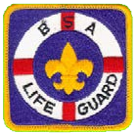  BSA Lifeguard | The BSA Lifeguard class is available to both adults and Scouts 15 years of age or older. All participants must be classified as a “swimmer.” BSA Lifeguard can be completed in one week but it requires a great deal of time. Candidates must attend all day sessions as well as doing practice lifeguarding during open swim periods and/or troop swim. This is not a merit badge.  A valid professional rescuer or equivalent CPR card is required to complete BSA Lifeguard – bring with you or obtain afterward.
Lifesaving | This is a very challenging merit badge, which requires a strong swimmer. You’ll need to swim continuously for 400 yards using each of the following strokes in a strong manner for at least 50 continuous yards: front crawl, sidestroke, breaststroke, and elementary backstroke before you can start the merit badge, so make sure you are in good shape. Prerequisite: Must be 1st Class or this will be a partial as we do not cover Req. 1.
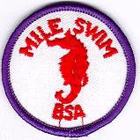  Mile Swim | Recommended only for strong swimmers – requires additional practice time daily. Must be classified as a “Swimmer”. To complete the Mile Swim, Scouts must report to the pool each day before breakfast; they will start with shorter distances to gain strength and to practice, with the aim of achieving a mile on Thursday. This is not a merit badge.
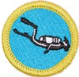  Scuba MB | SCUBA MB can be completed at Lost Pines. Scouts will be in the pool each morning on Monday, Tuesday and Wednesday. On morning of Thursday and Friday Scouts will go off camp to conduct their open water certification dives. Additional paperwork and parental permission forms are required to participate in SCUBA MB. These are sent to the participant’s Scout leader of record prior to camp. (Limit of 12 participants per week.)
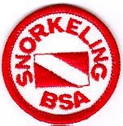  Snorkeling BSA | Recommended for strong swimmers. This program will instruct Scouts in the skills needed to safely snorkel in open water. This is not a merit badge.
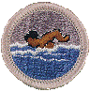  Swimming | Scouts must be qualified as a Swimmer on their swim test to take this badge. Swimming merit badge can be completed at camp if all the skills are demonstrated.
Aquatics - Waterfront Activities (on Lake Bastrop)
Lost Pines offers an array of merit badges: Canoeing, Motorboating, Rowing, Small Boat Sailing and Kayaking. In addition, we offer Stand Up Paddle Board, a BSA Aquatic Awards. All scouts must be classified as a “Swimmer” in order to participate in the class.
Merit Badge | Details
Canoeing | While canoeing on Lake Bastrop is great fun, it can be difficult for younger, smaller Scouts as physical strength is needed. Scouts should plan for an additional hour of practice daily during open boating time. Scouts must be “Swimmer” classified and should have at least some previous canoeing experience.
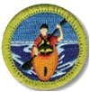  Kayaking | Kayaking MB is offered at Lost Pines and Scouts must be classified as a “Swimmer” to participate. While kayaking on Lake Bastrop is great fun, it can be difficult for younger, smaller Scouts as physical strength is needed. Scouts should plan for an additional hour of practice daily during open boating time.
Motor boating | Must be classified as a “Swimmer” and 13 years of age by start of camp. Learn how to steer small boats with outboard motors, properly coming alongside the dock and more.
Rowing | Rowing is fun, but is harder than canoeing. Scouts will need physical strength and coordination. Must be classified as a “Swimmer”. These skills might take some extra time to learn during free boating.
Small Boat Sailing | Must be “Swimmer” classified and have previous boating experience. Maximum of 14 Scouts per class; pre-registration is a must. Classes will be filled on a first-come, first-served basis. This is for Experienced Scouts – Must be at least 13 by start of camp.

Living History
The Living History program is designed to provide a taste of Early American culture. We offer the merit badges listed below, as well as lots of fun demonstrations and activities on Living History Night. Living History is located at the log cabin, across from the pool.
Merit Badge | Details | Eagle Required
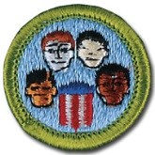  American Culture | Learn about the different cultures which make up our society. Visit a period log cabin with frontiersman furnishings.
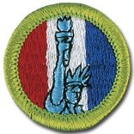  American Heritage | Every Scout swears to an oath that includes duty to his country. A better understanding of American heritage and the ways in which the past has led to our present nation is key to truly knowing what it means to be an American.
Basketry | Scouts will be provided materials for basketry kits (round and square basket) and stools.
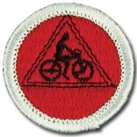  Cycling | The size of this class is restricted due to bikes and equipment required. If the class is full additional Scouts can be added if they bring their own bike and helmet.
Indian Lore | Learn about Native American history, including crafts and games. Allow additional time to complete projects.
Leatherwork | Leather will be provided by the MB instructor, but Scouts can purchase a leather kit from the Trading Post if desired.
Metalwork | Scouts will begin their work on this merit badge by learning about the properties of metal, how to use simple metalworking tools, and the basic metalworking techniques. Then they will practice using these tools and techniques before concentrating on the more intricate skills of one of four metalworking options. Foundry & Blacksmith options taught.
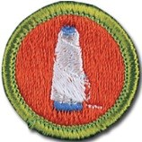  Textile | Learn about fabric and the different ways its manufactured. Die fabric from natural dies as well learning about the care of fabric.
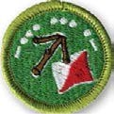  Signs, Signals, & Codes | Learn a wide variety of ways to simple communications that we use every day or for emergencies. Discuss some old ways we used to communicate and how secret codes have been made and how to make your own.
Woodcarving | Scouts need to bring their knife and Totin’ Chip (Requirement 1b). Kits are available in the Trading Post but blocks of wood are available from the instructor.
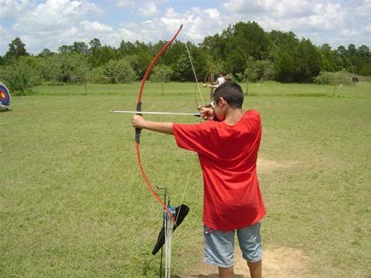
Shooting Sports
The Shooting Sports Area offers Scouts an opportunity to participate in exciting activities, with an emphasis on safety. Come learn a new skill or master one you already have, and of course, have a good time. The scheduled course time is used for instruction. Scouts may also attend the Open Archery, Open Rifle, and Open Shotgun times scheduled each day to practice and work on qualifying.

For safety reasons, visitors are not allowed in the Shooting Sports area, only staff members and Scouts registered for merit badge courses. Scouts not currently registered for the merit badges but needing to work on completing badges begun earlier should get permission from the staff.
Course sizes will be limited so that everyone will have plenty of time to shoot. Preference will be given to Scouts whose troop has pre-registered and provided merit badge selections in advance. Please be understanding if you are asked to change your schedule because the class is already full – this is necessary to provide a quality experience for all.

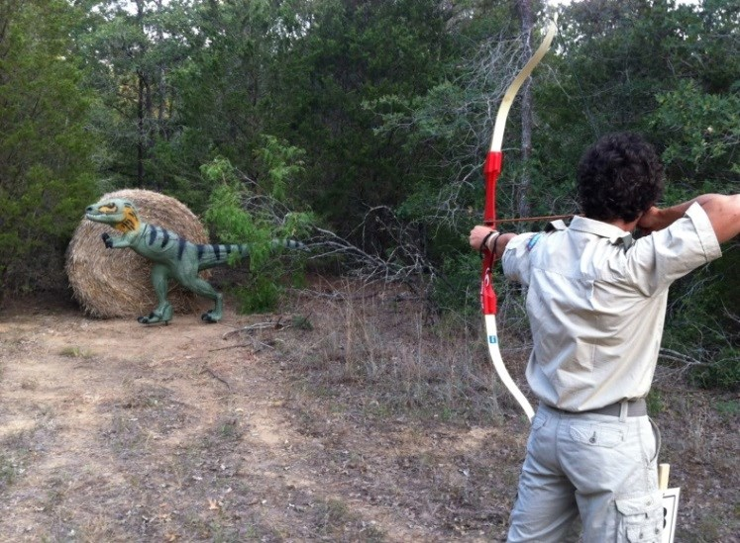
Action Archery for Scouts Wednesday night
Dinosaurs roaming the woods at Lost Pines? Only at the Action Archery range on Wednesday nights during summer camp!

The first 36 Scouts who sign up (individually) at the A-building can participate in the shoot. Participants must be enrolled in the archery merit badge (and have instructor approval) or those who have previously earned the badge. The event is held at 7:30pm on Wednesday.

Monday nights, we are asking every troop to send one adult to archery range orientation so that they can assist in supervision of the action archery shoot on Wednesday night. The Monday training will run for an hour and as a bonus, the leaders will get an opportunity to experience shooting a few targets on the range themselves. In addition, there is an open shoot for Monday nights during summer camp, the rifle and shotgun ranges will be open from 7:15 pm until dusk for unit leaders to come to the rifle and shotgun ranges and try their skills. Never shot? No problem. We will have trained NRA rifle and shotgun instructors on hand to help you. The best shot each night will receive a “Top Shot” certificate. This may be your opportunity to help your troop get more involved.
Merit  Badge | Details
Archery | Archery is great fun – some experience with previous range time and skill is desirable. It is suggested that the Scout also be available for the Open Archery period. Earning the merit badge includes achieving a certain score on a series of targets, which usually takes considerable time.
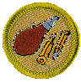  Rifle Shooting | It is suggested that the Scout also be available for the Open Rifle period. This is a challenging merit badge and most Scouts will find it difficult to qualify - to earn the merit badge they must not only learn safety, gun cleaning, etc. but must also achieve a reasonably high score on 5 targets with 5 shots each. For Experienced Scouts. Must be at least 12 years old.
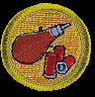  Shotgun  Shooting | Please be aware that the shotguns are heavy. Physically small Scouts may not be able to hold the shotgun and if so, will not be able to complete the course! Scouts must hit 24 out of 50 targets to qualify, and this can take considerable time. Scouts should plan on making use of Open Time to complete the merit badge. Scouts must be at least 13 years old and physically capable of handling the shotgun.

Nature – Environment – Conservation (Nat-E-Con)
Follow the yellow trail located behind the Trading Post to the Nat-E-Con area.
Merit Badge | Details | Eagle Required
Astronomy | Enjoy Lost Pines excellent observatory with 3 telescopes! This merit badge requires additional night activities; observation requirements may be impossible to complete if the weather is cloudy.
Chemistry | Class size is limited to 16 because of the number of experiments that need to be completed.
Environmental Science | This Eagle-required merit badge includes a great deal of paper work; some can be done at home. Plan for 2 added hours per day for field study and paperwork. This is a very challenging merit badge and involves a significant amount of writing.
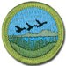  Fish & Wildlife  Management | Wildlife management is the science and art of managing the wildlife – both animals and fish. Learn how you can put these practices in place, projects at camp and in your own backyard.
Forestry | Plan on extra time for collecting leaves. It helps to bring a blank photo album or other binder to display your forestry collection.
Fishing | Scouts must catch one fish (Requirement #9) to complete the merit badge. Please encourage your scouts to bring their fishing pole and supplies to compliment the equipment provided by camp.
Fly Fishing | Learn the basics of fly-fishing, special knots used, types of flies used, how to cast, and what is the meaning and importance of catch and release.  Scouts must catch one fish (Requirement #10) to complete the merit badge.
Reptile &  Amphibian Study | Learn more about the wide variety of reptiles and amphibians found in Central Texas. Requirement #8 (Maintain one or more reptiles or amphibians for at least a month. Record the food accepted, eating methods, changes in coloration, shedding of skins, and general habits; or keep the eggs of a reptile from the time of laying until hatching; or keep the eggs of an amphibian from the time of laying until their transformation into tadpoles or larvae) cannot be completed at camp.
Soil & Water  Conservation | Be able to explain what a watershed is, how to protect it from erosion and what is water pollution. Learn about what we can do to help.
Space  Exploration | Build and fly your own model rocket! Space Exploration participants launch rockets at the assembly field Friday morning.
Scoutcraft
You'll find the Scoutcraft area along the path toward the waterfront! We've created separate areas for each badge. Each of these areas has a different flavor just waiting to be explored by ambitious Scouts. Practice cooking in a Dutch oven, use a compass, or use lashings to make a bridge.
Merit Badge | Details | Eagle Required
Camping | This merit badge cannot be completed at camp. It is helpful to do as much of the paperwork possible at home and bring to camp. Requirement 8d & 9a must be completed outside of summer camp although the week of camping nights at Lost Pines may be counted toward the 20 days/nights required for 9a. Requirements 5e, 7b, & 9b2 can be completed at camp if the scout brings their backpack and goes on a 4-mile hike. There will be time allotted on the tower for 9b6 rappelling to be completed.
Cooking | This is a great course for those extra-hungry Scouts and represents excellent experience for any Scout. This badge requires some cooking at home, thus requirements 6 & 7d cannot be completed at camp.
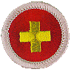  First Aid | Completing all of the first-aid requirements for Tenderfoot, Second Class, and First Class are a prerequisite. The first session is demonstration by each scout as described in requirement 1 and scouts not having these skills will be removed from the class. The badge can be completed at camp if the Scout brings items from home to make a personal first aid kit, not a store purchased kit. The material for this merit badge is not hard but there is a lot to do!
Emergency Prepardness | This merit badge cannot be completed at camp unless requirements 2c, 8b & 9a or 9b are prepared at home and brought to camp to show the instructor. Requirement 1 (earn First Aid MB) is not checked off by the camp unless the scout/unit has documentation.
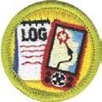  GeoCaching | The word geocache is a combination of "geo," which means "earth," and "cache," which means "a hiding place."
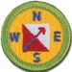  Orienteering | Learn about using a map, compass and what a 100-meter pace is. Identify map symbols and practice. There is not enough time to do all the courses required for this merit badge. If you have already participated in some orienteering events, bring documentation to the instructor for credit. Requirements 7 & 10 cannot be completed during class but if the Scout has troop/ patrol members to teach and time to do more course running on Friday then it may be possible to complete at camp.
Pioneering | Pioneering—the knowledge of ropes, knots, and splices along with the ability to build rustic structures by lashing together poles and spars—is among the oldest of Scouting's skills. Practicing rope use and completing projects with lashings allows Scouts to connect with past generations who used these skills as they sailed the open seas and lived in America's forests and prairies.
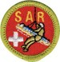  Search & Rescue | Learn about what a Search and Rescue team encounters, first aid skills needed, demonstrate readiness, hazards, and practice a scenario about finding your patrol using clue awareness, evidence preservation, tracking the subject and locating.
Wilderness Survival | Bring materials for making a basic survival kit (Requirement #5: Put together a personal survival kit and explain how each item in it could be useful). You will spend Wednesday night away from your troop camp in a shelter you build yourself!

Eagle Quest – First Year Camper Program
Eagle Quest is our first-year camper program designed to show the new scout how a patrol works with a staff member acting as the Patrol Guide for each patrol of eight scouts. The scouts will work on their rank requirements up to First Class. Patrols will be grouped by ranks so a new Scout needing to work on Scout rank up to First Class would not hold back a group of scouts just working on Second to First Class rank requirements. All Eagle Quest participants will be given a bandana and a compass.
All Eagle Quest Scouts will work on Swimming merit badge.
The following are the requirements which can be completed at camp if the patrol is able to get that far.

Rank | Details
Scout | 1a,b,c,d,e,f 2a,b,c,d 3a,b 4a,b 5 can be completed at camp.  Memorization will need to be worked on during non-program time. The meanings of the Scout Oath, Law and Outdoor code will be covered but unless the Scout can recite from memory as the requirement states the Scout will not be signed off for those requirements. Requirements 5 & 6 require parents and Scoutmaster and will not be covered.
Tenderfoot | 1c, 2b,c 3a,b,c,d 4a,b,c,d 5a,b,c 6a 7a 8 can be completed at camp.  1a requires the unit leader 1b living in a pitched tent, 2a preparing a meal, 6b,c takes 30 days, 7b service project, 9 Scout spirit, 10 SM conf. and 11 board of review (BOR) are not part of Eagle Quest even though some can be done at camp they should be done in the troop campsite with the unit.
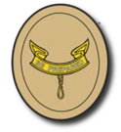  Second Class | 1b, 2a,b,c,d 2f,g 3a,b,c,d 4 5a,b,c,d 6a,b,c,d,e 8a,b 9a,b can be completed.  1a is 5 separate events, 1c select patrol site, 2e cook meal (Eagle Quest patrols only working on 2nd to 1st Class will complete this requirement), 7a,b,c 30 days, 8c,d,e parents and service project, 10 scout spirit, 11 SM conf. 12 BOR are not part of the Eagle Quest program.
First Class | 2a,b,c,d 3a,b,c,d 4a,b 5a,b,c,d 6a,b,c,d,e 7a,b,c,d,e,f 9a can be completed at camp.  1a,b 10 events, 2e 3 meals, 8a,b 4weeks, 9b,c,d events in community, 10 recruit Scout, 11 Scout spirit, 12 SM Conf. 13 BOR are not part of the Eagle Quest program.
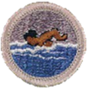  Swimming | Scouts must be qualified as a Swimmer on their swim test to take this Badge.
Totin’ Chip | Scouts will have the opportunity to earn their Totin’ Chip card.
Firem’n Chit | Scouts will have the opportunity to earn their Firem’n Chit card.

Climbing
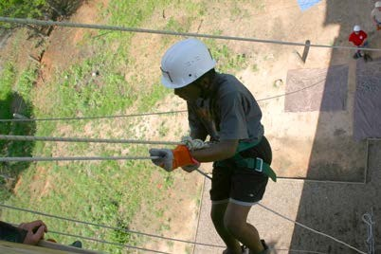
Do you love to climb? Do you feel freedom in leaving the flat earth behind? Do high and windy places invite you to come and explore? Maybe you've climbed trees and hiked to the tops of hills. Perhaps you've made your way up the stairs of a fire tower or to the observation floor of a tall building. If you've felt the excitement of being above it all, then climbing may be for you – find out on the tallest climbing tower in Texas! Climbing allows you to challenge yourself – it is a sport that does not require great physical strength, but it does demand mental toughness and the willingness to practice hard to master a set of skills. Class size is limited to 10 Scouts. Climbing participants must have shorts/pants with belt loops. For safety reasons, we cannot allow nylon running/basketball style shorts/pants. In addition shoes with good soles that are flexible are preferred.

Merit Badge | Details
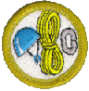  Climbing | Come and learn to climb and rappel on the highest climbing tower in Texas! If you read the merit badge book in advance and learn the knots, you’ll have more time at camp for actual climbing. This merit badge is for Scouts 13 and older.
Open Tower & Rappelling | Free time for climbing and rappelling and for Scouts that need to finish requirements in order to complete it, or who are currently enrolled in Climbing.

Scuba Merit Badge!!!
Lost Pines Scout Reservation is proud to provide Scuba merit badge. This program is available for Scouts 13 years and older by the start of the camp session that they attend. We have entered into an agreement with a local dive shop to provide Scuba merit badge for our Scouts at LPSR. Scouts will be in the LPSR pool during the entire morning sessions on Monday, Tuesday, and Wednesday. On Thursday and Friday mornings we will arrange to transport them to the Comal River in New Braunfels or Aquarena Springs for their open water dives.

Your Scouts will be able to earn the Scuba merit badge and be a certified SCUBA diver at the completion of camp. The diving instructor we have secured is a veteran staffer from Sea Base from 1996 – 2003 and is well known for his abilities and demeanor with youth. The cost for scuba is $300 per scout participant, and $375 for adults. This program fee is in addition to the regular summer camp fee. Scouts must prepay their scuba program fee by the final fees due deadline of May 1. This payment deadline is critical! We must receive these program fees and a commitment from your Scouts so that we can set up their accounts with the Scuba vendor. Your Scouts are responsible for reading and knowing the information and completing the on-line questionnaires in each of the six chapters of the dive book prior to arrival at camp. Name, birth date, and email will be asked from each Scuba participant in order for an on-line account to be set up for the class on May 1. As soon as you are registered with our Scuba vendor, you incur a $50 charge. This charge is not refundable under any circumstance.

There is a minimum of 8 participants to hold the class and a maximum of 12 participants each week. Scuba participants must fill out this medical form in addition to the standard BSA Medical parts A, B and C: http://www.tomsScuba.com/wp-content/uploads/2016/02/Medical-and-Physician-Guide.pdf

ATV Safety Course
The 14 year plus ATV participants will complete the ATV Safety Institute beginning rider course.
Scouts must receive parental permission and turn in the ATV Participation Form found at http://bsacac.org/my_files/atv_h_h_form_430-048_wb.pdf at check-in.

Scouts must also wear long sleeve shirts, long pants and over the ankle boots or they will not be allowed to participate in this introduction to safe operations of ATV.

Silver Pines Adventure
Your week is filled with exciting activities such as canoe fishing, Scuba orientation, and Water Sports. Then it’s back to Lost Pines for Archery and Shotgun Shooting. You need to be at least 14 years old and pass the swim test. Max of 12 youth participants each week and at least one adult from one of the units involved will need to attend the Hero Water Sports trips to meet youth protection guidelines.

Leader Training Options
Note: this list is subject to change before and during camp.
Training | Date & Time | Details
Scoutmaster /  ASM Position  Specific Training | Monday  8:45-11:45am | Conducted in air-conditioned Lindsay Lodge to start the path for SM and Assistant Scoutmasters position required training.
Intro.to Outdoor Leader Skills | Mon 3-5pm  Tues-Thur 8:45-11:45am | First Aid in Lindsay Lodge Monday afternoon. The rest is conducted in the adult training pavilion at Eagle Quest to see troop skills in action. Class is all 3 mornings and 1 afternoon. If items are missed then some classes can be made up on Friday.
Committee Challenge | Tue 3-5pm | Conducted in air-conditioned Lindsay Lodge for all members of the troop leadership
Archery | Monday night after dinner | We are asking every troop to send one adult to the archery range orientation so that they can assist in supervision of the action archery shoot on Wednesday night. The Monday training will run for an hour and as a bonus, the leaders will get an opportunity to experience shooting a few targets on the range themselves.
Climbing Instructor | Weekday Mornings | Provided by the Council Climbing Committee. Climbing Instructor training will allow you to reserve DOC’S Tower and take your Scouts on exciting climbing and rappelling programs. The fee is $25. Subject to availability of CAC Climbing Staff.
Safe Swim Defense | Monday  1:15pm | Before a BSA group may engage in swimming activities of any kind, a minimum of one adult leader must complete Safe Swim Defense training.
BSA Lifeguard | All day  Monday -Friday | Adults can join the Scouts and become a BSA Lifeguard.
First Aid Certification | TBA | Depending on which instructor and their certifying agency this will cost $5-$15.
CPR Certification | TBA | Depending on which instructor and their certifying agency this will cost $5-$15.

Summer Camp Checklist

February
- Review Medical Forms
  - Have parents schedule with their doctors for Part C’s as needed
  - Tetanus booster within last 10 years
  - Physician signature within last 12 months (as of camp date)
  - Signature if parent wants to authorize over-the-counter medication
- After gathering medical forms, draft Medical Log (what medications are expected for which Scouts)
- Scouts review Merit Badges and course options
- Recruit parents for summer leadership and make sure they are registered with BSA
- Determine date when camp will be canceled, or scout number reduced if Troop does not enough have enough volunteer adults leaders (no later than April 30)
- Schedule time in your calendar to complete the items in this checklist

April 1
- Deposit first payment
- Leader gathers Scouts’ Merit Badge and course requests and enters in DoubleKnot
- Assign adult to manage transportation to and from camp
- Make sure all youth attending camp are registered with BSA

April 15
- Request Camperships if needed

May 1
- Deposit final payment
- Submit adult leadership paperwork:
  - YPT Aging Report for your Troop (found on my.scouting.org or YPT Certificates)
  - Texas Youth Camps Safety and Health Act form completed in DoubleKNot
  - BSA Membership Roster from my.scouting.org or your Council Registrar
- Conduct swim checks

Four weeks before camp
- Review camp menu and individual dietary needs. Determine meal plan for each attendee: camp menu, gluten-free, vegetarian or bring-your-own (for multiple allergies)
- Summer Camp Scoutmaster meets with SPL to review Troop trailer and preparations

Two weeks before camp
- Senior Patrol Leader holds Patrol Leaders Council meeting to discuss summer camp:
  - Create camp patrols and confirm leaders
  - Review Model Campsite checklist with camp leaders
  - Confirm gear to bring
  - Create Duty Roster
- SPL follows up with Summer Camp Scoutmaster on results of PLC discussions
- Expect a phone call from Business Manager to verify information and answer questions

One week before camp
- Troop packs trailer with required camp gear
- Parents confirm original prescription containers ready
- Review Lost Pines check-in video
- Print class schedule for all Scouts attending
- Obtain signed ATV Permission forms for any scouts participating in ATV program

Troop travel day
- Troop departure
  - Troop packs trailer with Scout gear
  - Medications presented to Medical adult. All must be in original packaging and must not be expired. Adult puts all medications in locked container.
  - Parents bring signed medications/health status form confirming health conditions and adding any last-minute details
  - Medication Log – parents confirm medications, dosage and timing
  - Troop permission slips collected
- Troop check-in
  - Assign adult to handle registration
  - Assign adult to handle medical
  - Assign adult pairs to go on camp tour with scouts and camp Troop Guide

Map to Lost Pines
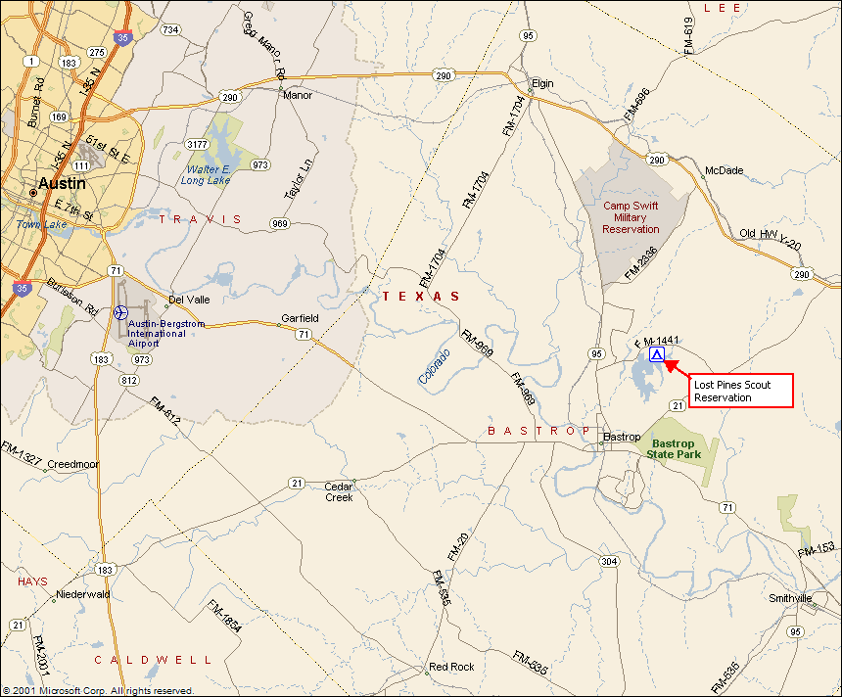

785 FM 1441, Bastrop, Texas 78602

To reach Lost Pines Scout Reservation from Austin using Hwy 290:
East on Highway 290 to Elgin.
South on Highway 95 approximately 12.8 miles to FM 1441.
East on FM 1441 3.4 miles.
South into Lost Pines Scout Reservation.

Or, reach Lost Pines Scout Reservation from Austin using Hwy 71:
East on Highway 71 to Bastrop.
North on Highway 95 approximately 3.8 miles to FM 1441.
East on FM 1441 3.4 miles.
South into Lost Pines Scout Reservation.
(Report to Lindsay Lodge for check in)
Lost Pines Camp Map

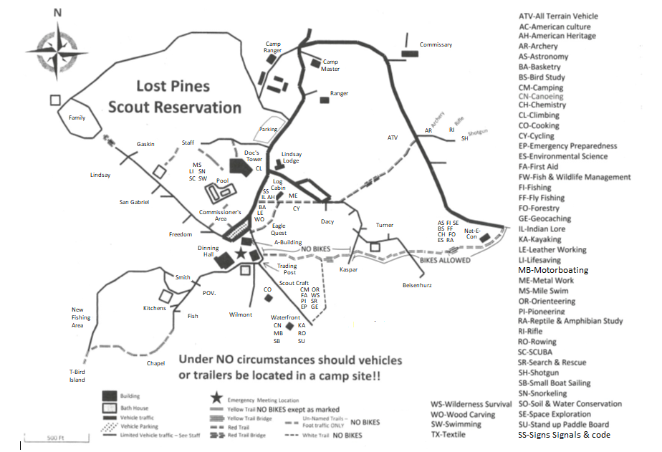

Note: *These Campsites require $10/tent rental*
Dacy, Fish, Freedom, San Gabriel, Smith, Turner, Wilmot
Cots and sleeping materials are not provided

Equipment Checklists
Individual Scout Equipment:

Scout Uniform and Belt
Socks and Scout Socks (7 or 8 pair)
Shorts and Scout Shorts
2 - 3 T-shirts (no tank tops)
Shoes (completely closed) or Hiking Boots NO CROCS OR HIKING SANDALS
Water shoes (Aqua socks, etc.) for Waterfront
activities
Cap or Hat for sun protection
Underwear
Pajamas or sleeping clothes
Sleeping Bag or 2 blankets & sheet
Pillow
Cot
Personal First Aid Kit
Poncho or Rain jacket
Towels & washcloth
Soap and Shampoo
Toothbrush & Toothpaste
Comb, Brush, & Mirror
Flashlight & Extra Batteries
Pocket Knife & "Totin Chip"
Insect Repellent (non-aerosol)
Swim Suit (no cut-offs or bikinis)
Sun Screen
Boy Scout Handbook
Water Bottle
Spiral Notebooks
Pen or Pencils
Completed Merit Badge Work
Spending Money
Optional:
Backpack
Fishing Rod & Tackle
Camera
Bible or Prayer Book
Work Gloves
Dirty Clothes Bag
Combination Lock
Mosquito Netting
Watch

For First Aid, Emergency Preparedness, Camping, and Wilderness Survival review merit badge requirements for kits-backpack (assemble at home and bring to camp).
For ATV Safety Course bring over the ankle boots, long sleeve shirt and long pants.

MARK EVERYTHING WITH SCOUT’S NAME & TROOP NUMBER
- Personal valuables (watches, wallets, money, chargers) should not be left out in the open at camp.
- Completely enclosed shoes are to be worn at all times unless you are in your tent, at the pool, or in the shower.
It would also be a good idea to review the Leave No Trace principles while preparing for Camp – especially “plan ahead and prepare”

Principles of Leave No Trace
- Plan Ahead and Prepare
- Travel and Camp on Durable Surfaces
- Dispose of Waste Properly
- Leave What You Find
- Minimize Campfire Impacts
- Respect Wildlife
- Be Considerate of Other Visitors

Troop Equipment

Patrol Flags
Lanterns (propane is best)
Matches/Lighters
Dining Fly(s), poles, & stakes
Rope
Tents (if you have them), poles & stakes
5 Gallon Water Jugs
Ice Chests
Trash Bags
Lockable Storage Container
Troop First Aid Kit
Compass
Hammers & other hand tools
Shovels, Rakes, Hoes, Bow saws, loppers
Rolls of Surveyor’s marking tape
Lawn chairs

Campsite entrance/gateway materials:
Troop Sign (should include Troop number)
Troop Flag
U.S. Flag
Twine & poles for lashing
Bulletin Board:
Camp Roster
Troop Duty Roster
Scout Schedules
Emergency Procedures
Push pins, etc. for bulletin board
Clock (optional, but helpful)
Paperwork:
Troop Advancement Records
Troop Merit Badge Library
Troop Leaders Guide Book (this document)
Copy of O.A. Unit Election form (if call outs are to be done at camp)

Tents must display the warning “No Flame In Tent” on the outside near the door way. See tent rental form in the appendix if you need to rent tents.

Don’t forget to bring items such as thumbtacks, duct tape, vice grips, sharpening stone & oil.

Troops can buy additional ice at camp to put in your 5-gallon water jugs.

Check with the Camp Commissioners if you need anything.

Texas Youth Camps Safety and Health Act FORM
Due to: BSA-CAC, 12500 North IH-35, ATX, 78753 or fax 512-926-6870 by May 1.
On April 16, 2006, the state of Texas passed into law new regulations that affect the Texas Youth Camps Safety and Health Act (Title 25, Part 1, Chapter 265, Subchapter B, Rule 265.12(f)(f1a)(f2)(g). This new rule affects all licensed youth camps in the state of Texas and became effective June 1, 2006. In order for the Boy Scouts of America and the Capitol Area Council to comply with the new state law on protecting our youth camp participants we must require each leader to provide the items listed below. Your understanding and assistance in this important matter is greatly appreciated.

For every adult age 18 and older who will be attending camp even for one day, each unit must provide all of the following items for that person to be able to attend camp.

This act requires all adult volunteers, 18 years and older, to undergo a criminal background check. By submitting this form you are authorizing a criminal background check of yourself. This check will be made from public record sources. You will have an opportunity to review and challenge any adverse information disclosed by this check.

TROOP Number: ________________ CAMP WEEK:______________

Adult applicant FULL LEGAL name: (first, middle, last) ______________________________________________
Address: ____________________________________________ Date of Birth: ___________________
City,ST Zip: __________________________________________ Day Phone: ____________________
Email: _____________________________________________________________________________
Signature:____________________________________________Date: _________________________

Please Answer the Following Questions
Do you use illegal drugs? YES NO
Have you ever been convicted of a criminal offense? YES NO
(If yes, explain on back of page)
Have you ever been charged with child neglect or abuse? YES NO
Has your driver’s license ever been suspended or revoked? YES NO
(If yes, explain on back of page)

Other than the above, is there any fact or circumstance involving you or your background that would call into question your being entrusted with the supervision, guidance, and care of youth? (If yes, explain on back of page)

Character references: Contact phone:
1.__________________________ ____________
2.__________________________ ____________
3.__________________________ ____________

Submit this form to Capitol Area Council by May 1 via mail, fax or email to: 12500 North IH-35, Austin, TX 78753 or 512-926-6870 fax or 564roster@scouting.org
Date application received _______________ OFFICE USE ONLY
Date application approved ________________

Date application sent to Camp Director ___________

Approved by _______________________Title ____________________________

BOY SCOUT SUMMER CAMP

Pre-Camp Swim Check
Units doing pre-camp swim checks must follow the Safe Swim Defense guidelines and policies outlined in the Guide to Safe Scouting and bring the form below to camp to submit at check-in. Swim check must be conducted by a certified Aquatics Instructor, certified lifeguard (either BSA or American Red Cross), swimming instructor or swim coach. Please attach a copy of testers credentials.
Unit-sponsored Swimming Ability Classification
Camp Week | Campsite |  |  |  | Camp Scoutmaster
Troop Number |  |  |  |  | Address
Council | District |  |  |  | City |  | State |  |  | Zip
e-mail address |  |  |  |  | Home Phone |  |  | Work Phone
Submission of this form to Lost Pines Scout Reservation certifies that the unit named above has conducted its own swimming ability classification testing following the guidelines of Safe Swim Defense as defined in the Guide to Safe Scouting. The unit requests that this classification be used for aquatics activities at Lost Pines Scout Reservation during the camp term above in lieu of the ability test normally provided by the camp staff at the beginning of camp. |  |  |  |  |  | Date Swim-test conducted:
 |  |  |  |  |  | Location of test:
 |  |  |  |  |  | Test conducted by:
Signature:

Qualification:
NAME |  | Non-Swimmer | Beginner | Swimmer |  | NAME |  |  | Non-Swimmer |  | Beginner | Swimmer
1. |  |  |  |  |  | 21.
2. |  |  |  |  |  | 22.
3. |  |  |  |  |  | 23.
4. |  |  |  |  |  | 24.
5. |  |  |  |  |  | 25.
6. |  |  |  |  |  | 26.
7. |  |  |  |  |  | 27.
8. |  |  |  |  |  | 28.
9. |  |  |  |  |  | 29.
10. |  |  |  |  |  | 30.
11. |  |  |  |  |  | 31.
12. |  |  |  |  |  | 32.
13. |  |  |  |  |  | 33.
14. |  |  |  |  |  | 34.
15. |  |  |  |  |  | 35.
16. |  |  |  |  |  | 36.
17. |  |  |  |  |  | 37.
18. |  |  |  |  |  | 38.
19. |  |  |  |  |  | 39.
20. |  |  |  |  |  | 40.
Return to: Capitol Area Council, 12500 N IH-35, Austin, Texas 78753 — Bring copy to camp.

Medication Log
Medication Log
Camp Week |  | Campsite |  |  | Camp Scoutmaster
Troop Number |  |  |  |  | Address
Council |  | District |  |  | City |  | State |  | Zip
Office Use |  |  |  |  | Number of Bottles:
SCOUT’S NAME | MEDICATION NAME/DOSE |  | AFTER  BREAK-FAST | NOON |  | 4:00 PM |  | AFTER  DINNER |  | BEFORE  BED
Please fill out and bring to Camp. Turn in during Medical re-check.

MEDICAL SCREENING
Screening of Campers/Staff: On arrival for any camping period in excess of 72 hours, each participant (youth, adults, and staff) must be screened by the camp Health Officer or other designated and trained staff member using guidance in Camp Health Officer Training, No. 19-141. All such screenings shall be done in a way that protects the privacy of the participant or staff member being screened.

At a minimum, the camp health officer shall follow a screening protocol that makes him or her aware of
1. medications being taken by the participant,
2. special health needs that limit participation, and
3. allergies to food or medicine, as well as
4. emergency medications that may be needed and maintained by the participant.

Additionally, the camp Health Officer will ensure that the appropriate permissions for participation have been granted by both the parent/guardian nd the examining physician. At the time of the screening, arrangements are made for the secure storage and dispensing of any medications.

During the screening, the camp health officer will prepare a list of special health needs (those that affect participation in camp activities or require medication or other attention) and review them with the camp director and appropriate staff members on a need-to-know basis only.

The camp health officer will also verify that the appropriate unit leaders are informed of
1. campers with limitations, special needs, or life-threatening conditions, should they not already be informed, and
2. ensure that emergency medicine (epinephrine, asthma inhalers, etc.) is present and not expired.
HS-504; HS-505 (B3); HS-506 (G)

Camp Health Model Policy and Procedure
Manual
BSA #680-048
2013 Printing
Identifying significant circumstances arising after completion of the health history is critical, but flexibility is allowed in how this information is obtained and documented. Pertinent information includes
(1) any visit to a doctor or clinic since the last
exam;
(2) any recent illness, injury, rash, or allergic reaction;
(3) fever or other signs of illness or infection in the last 48 hours (i.e. nausea, vomiting, diarrhea, cold):
(4) contact with sick friends or family members
in the last 48 hours
(5) any ongoing treatment or medication;
(6) any medication taken 30 days prior to camp; and
(7) if the person feels and looks fine at present.

Generally, face-to-face screening of individual participants should be done by a health-care professional or other adult designated and trained by the camp health officer. In some circumstances, it may be sufficient for screening purposes for the unit leader or other adult familiar with the individual participants to identify anyone needing special health or medical consideration or limitation of activities. To be sufficiently informed for this assessment, the adult leader should personally observe and talk to each participant. If the unit leader or camp leadership is not confident with the assessment, the camp health officer should designate an adult to interview and assess the participants.

Camp Health and Safety
BSA #19-308
2007 Printing

HEALTH SCREENING
Staff or Unit/No.
To be completed by unit leader before check-in at camp. This form will be reviewed with you by the camp health officer or designated staff member at check-in.
Please list for the camp health officer the names of campers or staff who:
1. Are taking medicines currently.
2. Have special health needs that limit participation.
3. Have allergies to foods, medicines, and insect stings.
4. Have emergency medicines they keep with them.
5. Have had a change in circumstances since their Health Screening was done, including:
a. any visit to a doctor or clinic since the last exam;
b. any recent illness, injury, rash, or allergic reaction;
c. fever or other signs of illness or infection in the last 48 hours (i.e. nausea, vomiting, diarrhea, cold);
d. contact with sick friends or family members in the last 48 hours;
e. any daily medication taken 30 days prior to camp.
If any of these are present, does the person feel and look fine at present?
Name | Screening notes

Unit leader signature: ______________________________________________Date: _____________

Leader printed name: _________________________________________

Capitol Area Council Campership Assistance

Campership Assistance Request
How this Program Works:
Camping is one of the methods of delivering the Scouting Program. The Capitol Area Council wants to make sure every Scout has an opportunity to have a mountain top experience at camp. Please be aware that additional assistance is usually available through the Scout’s Unit and Chartered Organization and that these resources should be asked before applying for a campership. All Scouts who receive campership aid should earn or provide part of their fee, in keeping with “A Scout is Thrifty”. After completing the Assistance Request, submit it to the Council Event Coordinator who will have it reviewed. If approved the Scout family will be provided up to 50% of the cost of camp (subject to availability and budget).
This program has limited resources and availabilities:
To help ensure that we continue to receive financial gifts to keep these programs possible, you are asked to include a brief letter with your assistance request that can be shared with possible donors. We ask that this letter be from the Scout and include what Scouting means to them and how attending this camp will have an impact.
Contact Information
Scout’s Name: __________________________________ Scout’s Rank: _________________ Scout’s Unit: ____________
Family Contact Person: _____________________________________ Contact Phone: _______________________ Contact Email: _____________________________________________________

Scouting Background
When did this Scout earn their last rank advancement? ________________________________________
Did this Scout attend camp the previous summer? ________________________________________
Did this Scout participate in the most recent Council Popcorn Sale? ________________________________________
Are other family members registered in Scouting? (if so, who) ________________________________________
Has this Scout received a campership in the past? (if so, when) ________________________________________

Camp Information (check one)
[ ] Cub Scout [ ] Webelos [ ] Boy Scout [ ] NYLT [ ] Hornaday [ ] Wood Badge (adult)
Please indicate camp type (day, summer, winter, etc.) _______________________ Camp dates: _____________________
Assistance Needs
Total Annual Household Income (from all sources): _____________ Total Number of Household Members: _____________
Does the Family receive free or reduced price school meals? Yes No (Circle One)
How Does the Scout plan to fund Camp?
Family/Scout Contribution $_____________ Unit/Chartered Org Contribution $______________ Requested Amt $______________
A Scout is Trustworthy, The above information is True, Scouts Honor.
Parent/Guardian Signature: ________________________________ Date: __________________________
Council Event Coordinator Signature: ________________________________ Date: __________________________

For Official Use Only
___ Unit asked to help with camp ___ Scout currently registered
___ Chartered org asked to help with camp ___ Scout active in programs
___ Date received ___ Personal letter attached
Assistance Committee Recommendation ____________________________________

